+91-8048017823

Shubham Enterprise

http://www.projectspipefittings.com/

We are leading wholesalers, suppliers and exporters of a wide variety of Stainless Steel Components. Our wide assortment of products, utilised in India’s top Oil
- Gas firms and Power Plants, are held in high esteem across the country.

About Us

Established in the year 2006, "Shubham Enterprise", is the leading wholesaler, supplier and exporter of a superior range of Stainless Steel Components, that are aiding a host of top companies in their day-to-day industrial operations. Our range of products include Pipe Tubes and Tubing, Outlets and Forged Fittings, among others. We are working with highly trustworthy manufacturers and vendors, who utilise only premium quality raw material to fabricate the products. Having adhered to strictly laid out industry guidelines, we supply only quality products that are renowned for their corrosion and impact resistance, greater tensile strength, optimal performance, dimensional accuracy and durability. We work with trusted manufacturers and vendors, who have engaged with us since our inception. We are on the verge of securing a Certification. We are exporting globally.

As renowned suppliers, it is our duty to do a thorough homework on our manufacturers. This is why we have employed top quality procurement agents and quality experts, who visit the site of the manufacturer and procure only quality units. Our manufacturers are well-equipped with a facility and advanced machinery. We have set up a vast warehousing unit so as to adhere to bulk demands. Our products are inspected closely by the quality control unit before they are shipped to various parts of the world.

In less than a decade, we have earned the trust of many of India’s...

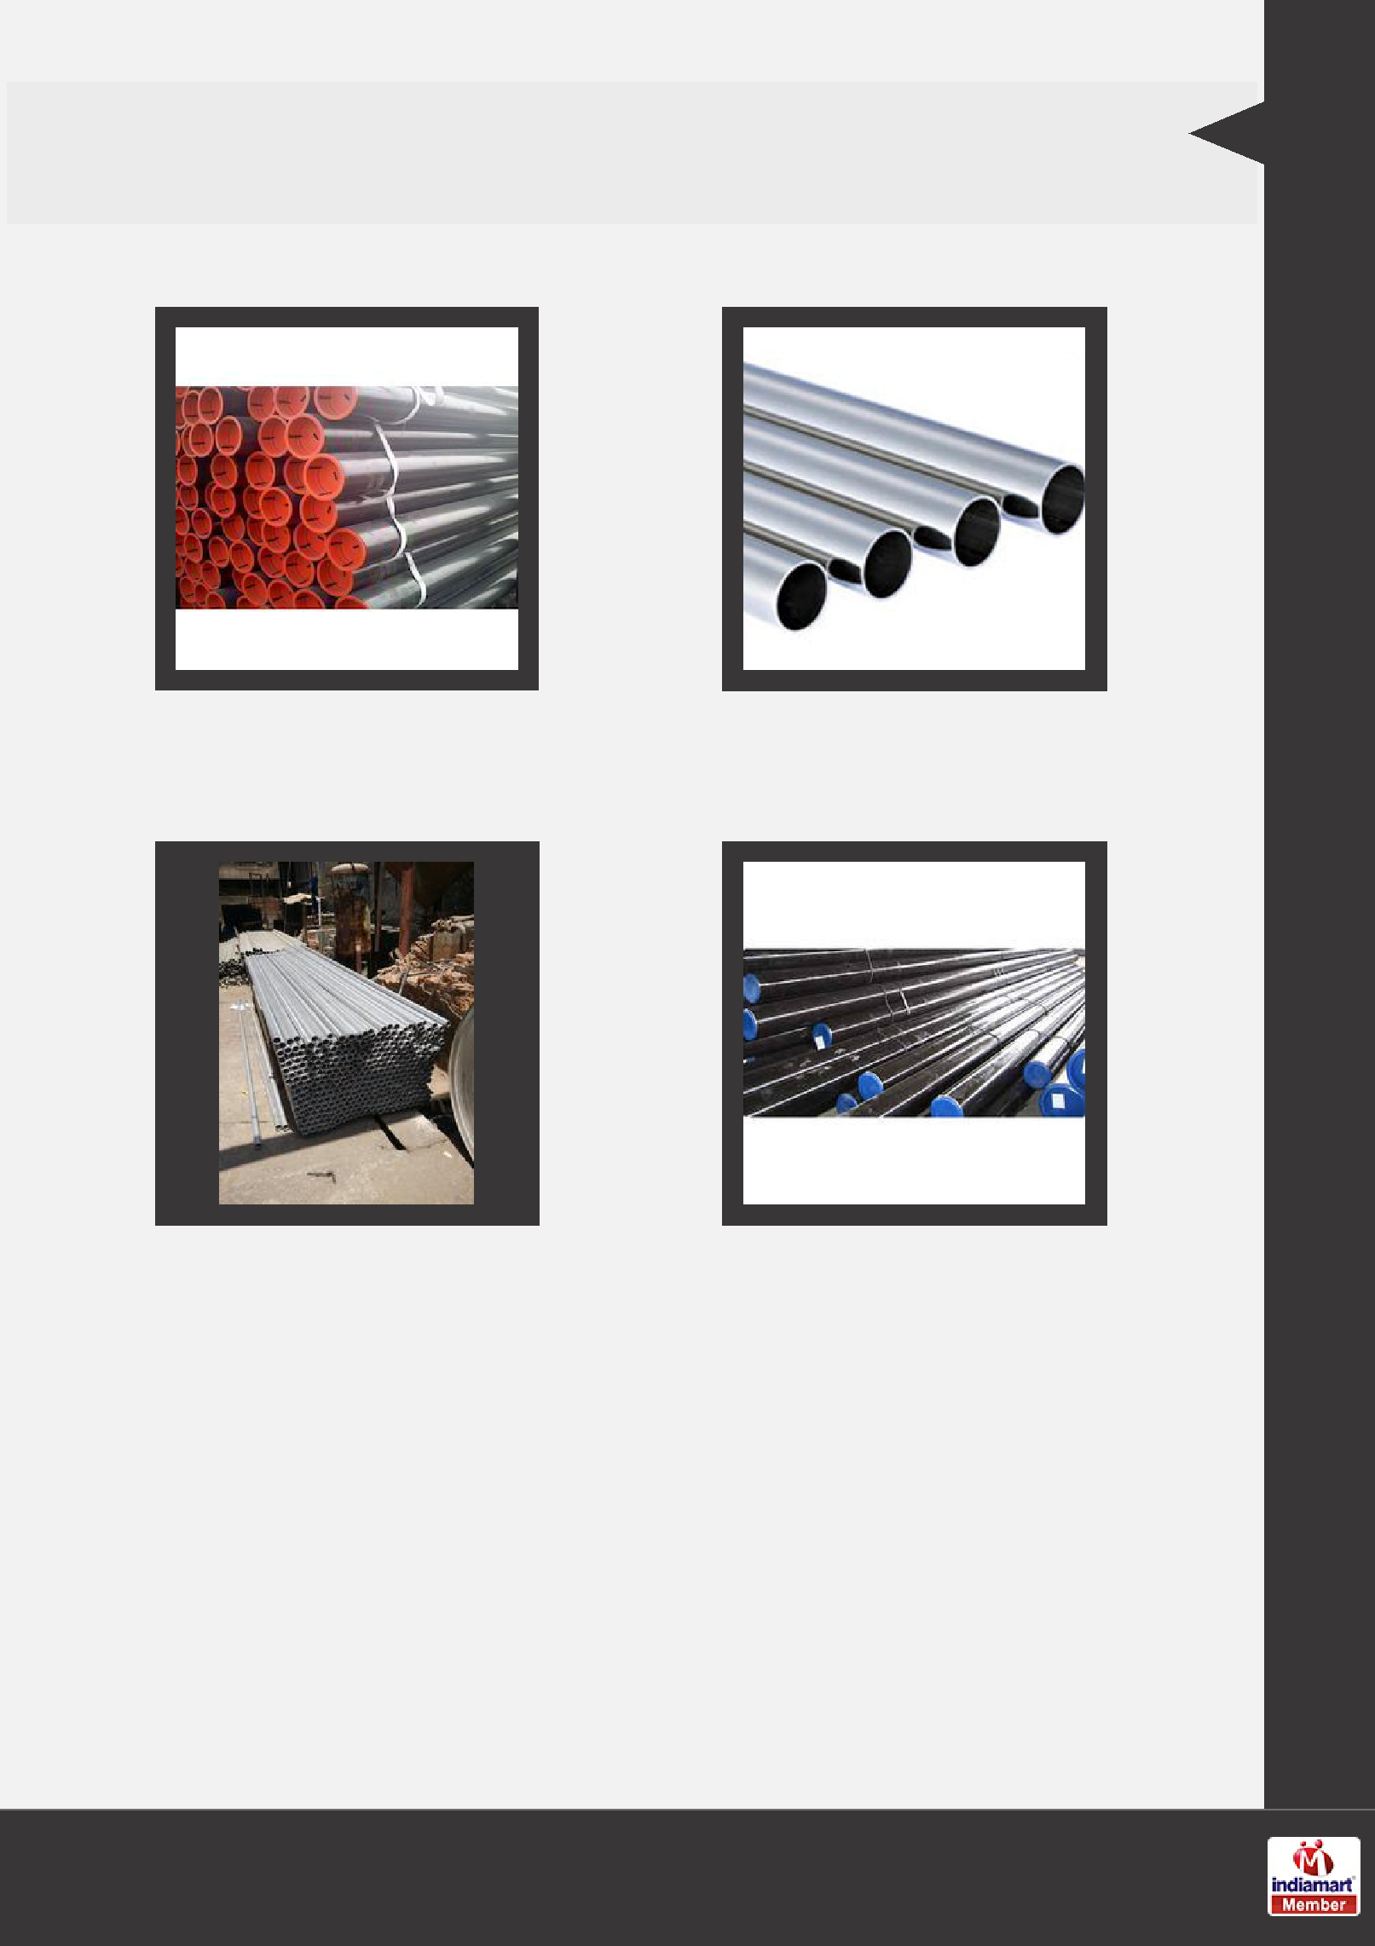
PIPE TUBES

Carbon Steel Pipes Inconel Pipe Seamless Pipe

Monel Pipe Alloy Steel Pipes & Tubes

Our Products

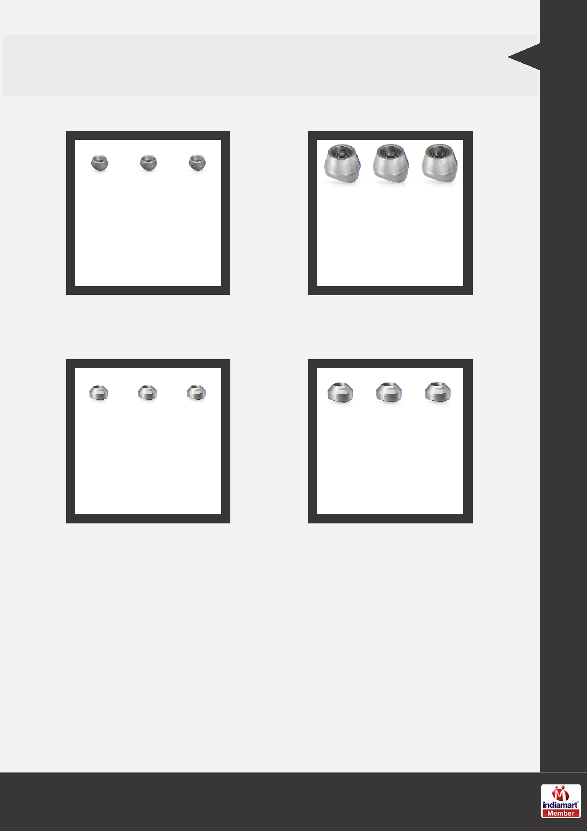
SS PIPE ACCESSORIES

Threadolet SS Braz Olet

Sockolet Ss Weld Olet

Our Products

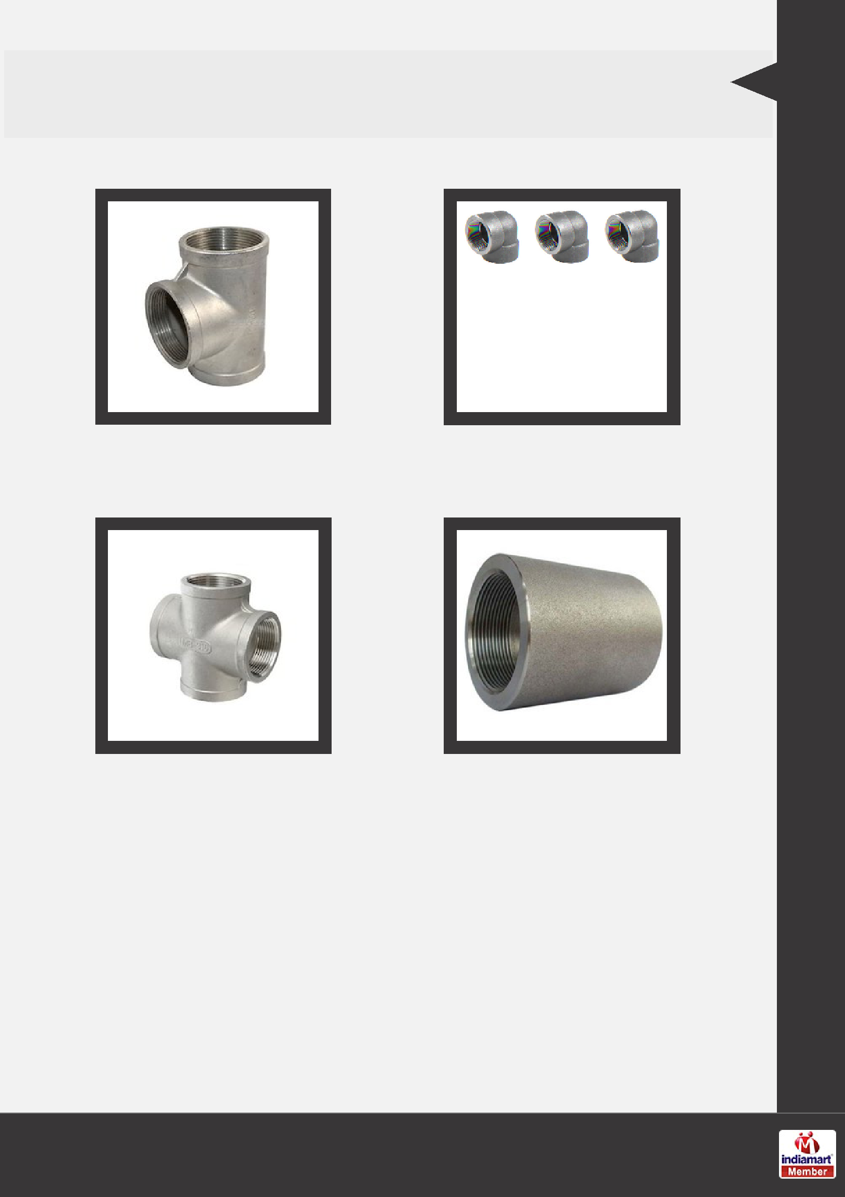
FORGED FITTINGS

SS Tee Forged Elbow

Cross Pipe Fitting Full Coupling Fittings

Our Products

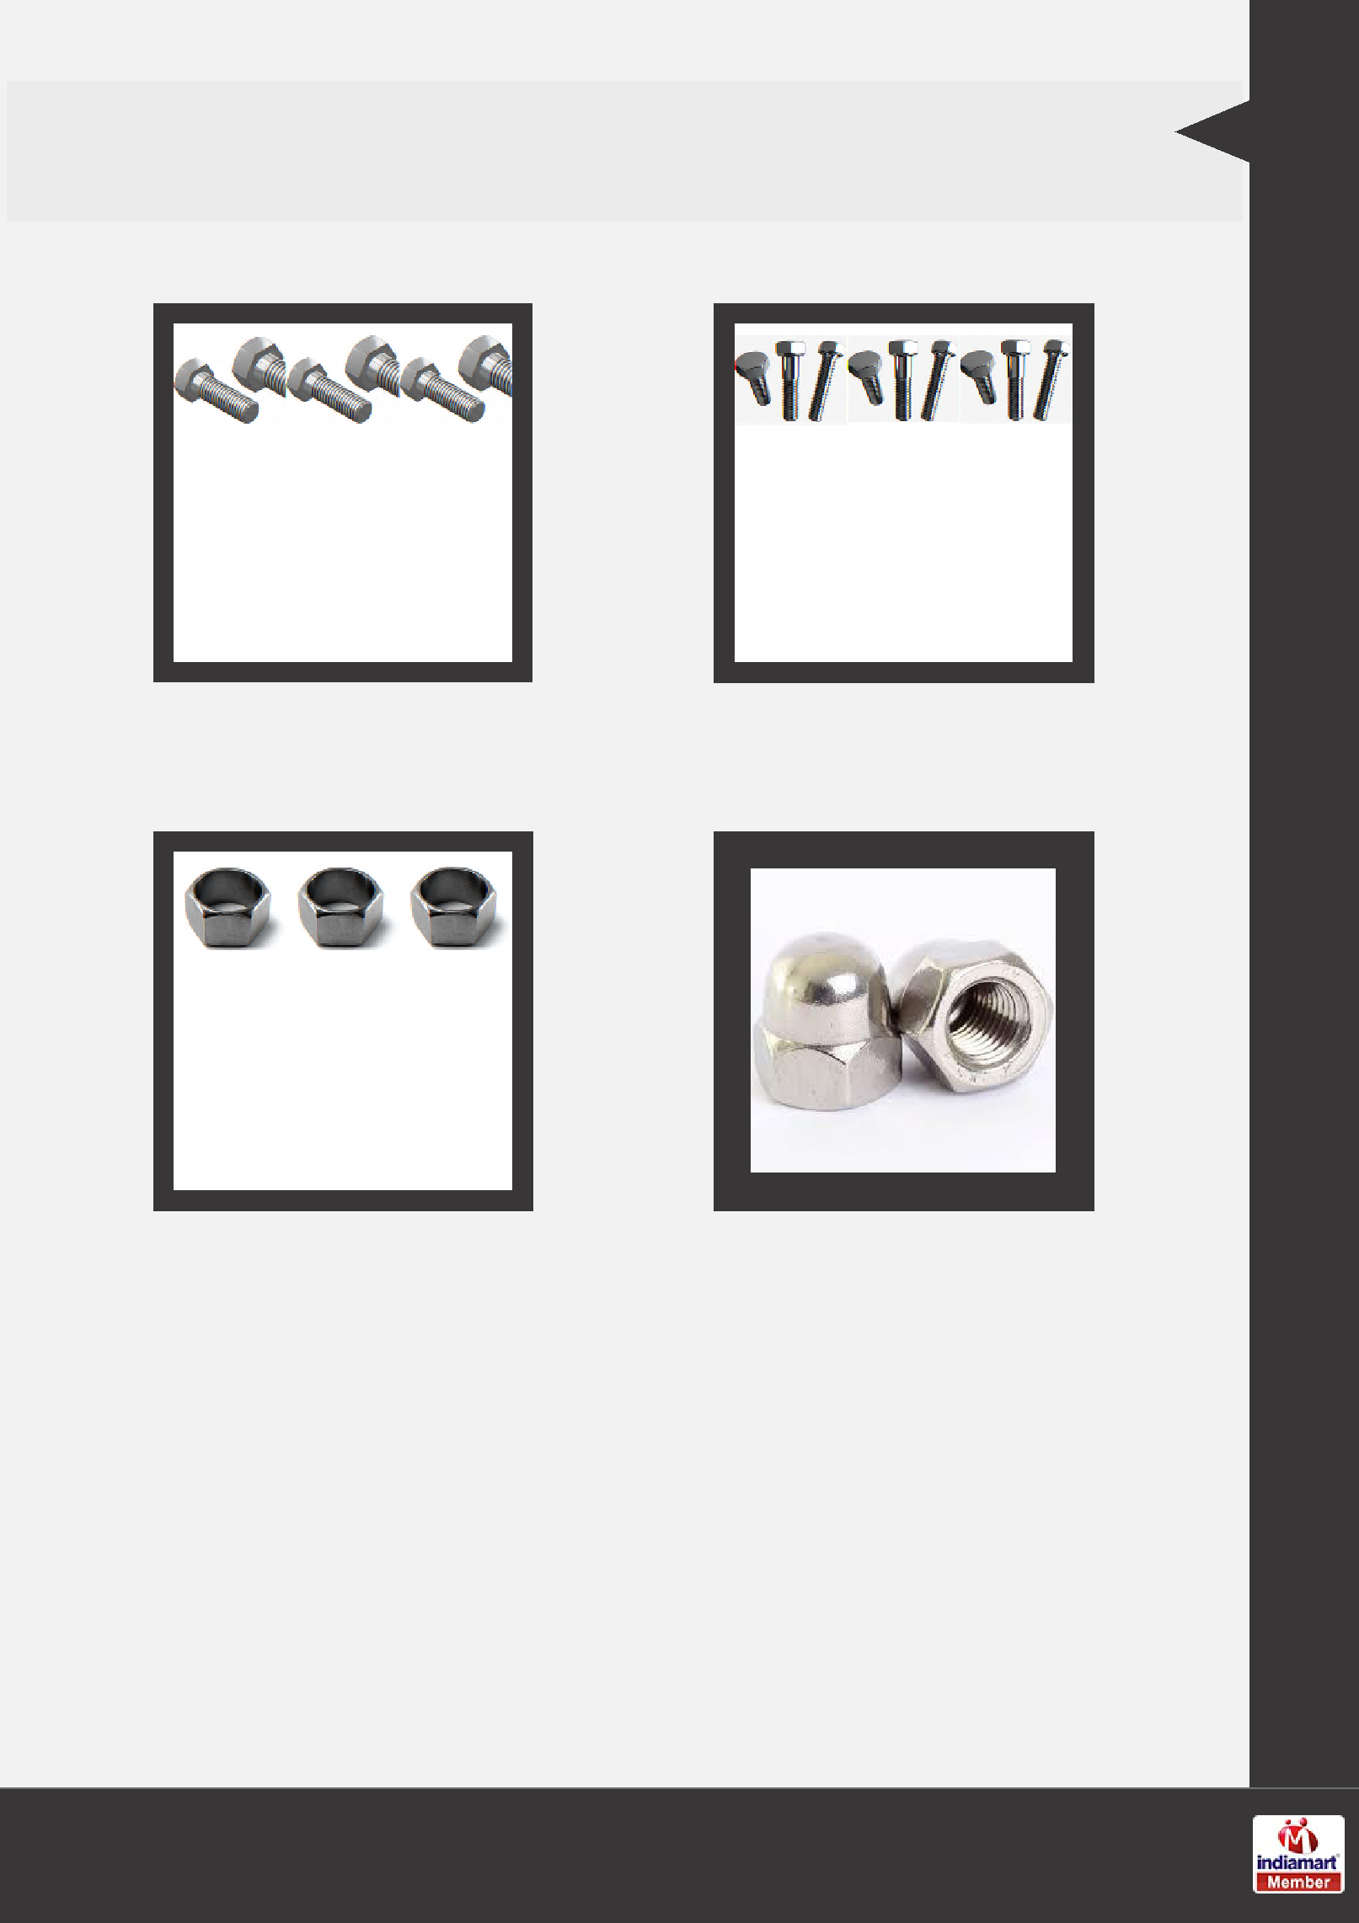
FASTENERS NUTS BOLTS

Hex Head Bolts Hexagonal Bolt

Hex Nut Dome Nuts

Our Products

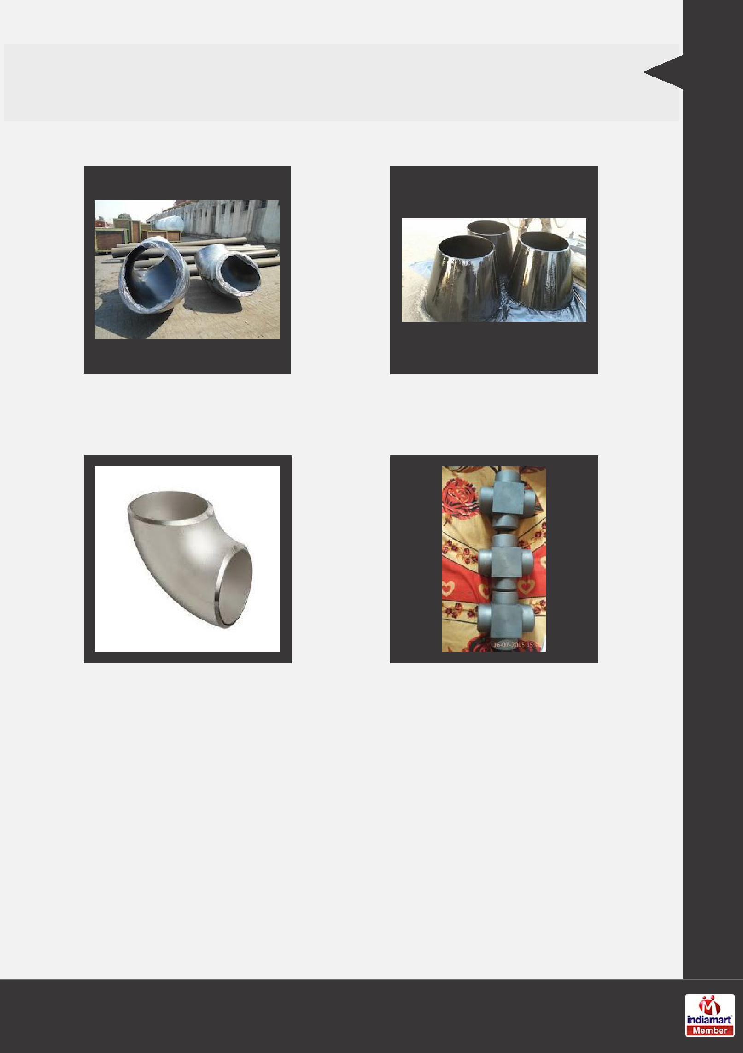
BUTT WELD FITTING

Elbow Eccentric Reducers

Elbow LR Cross Fittings

Our Products

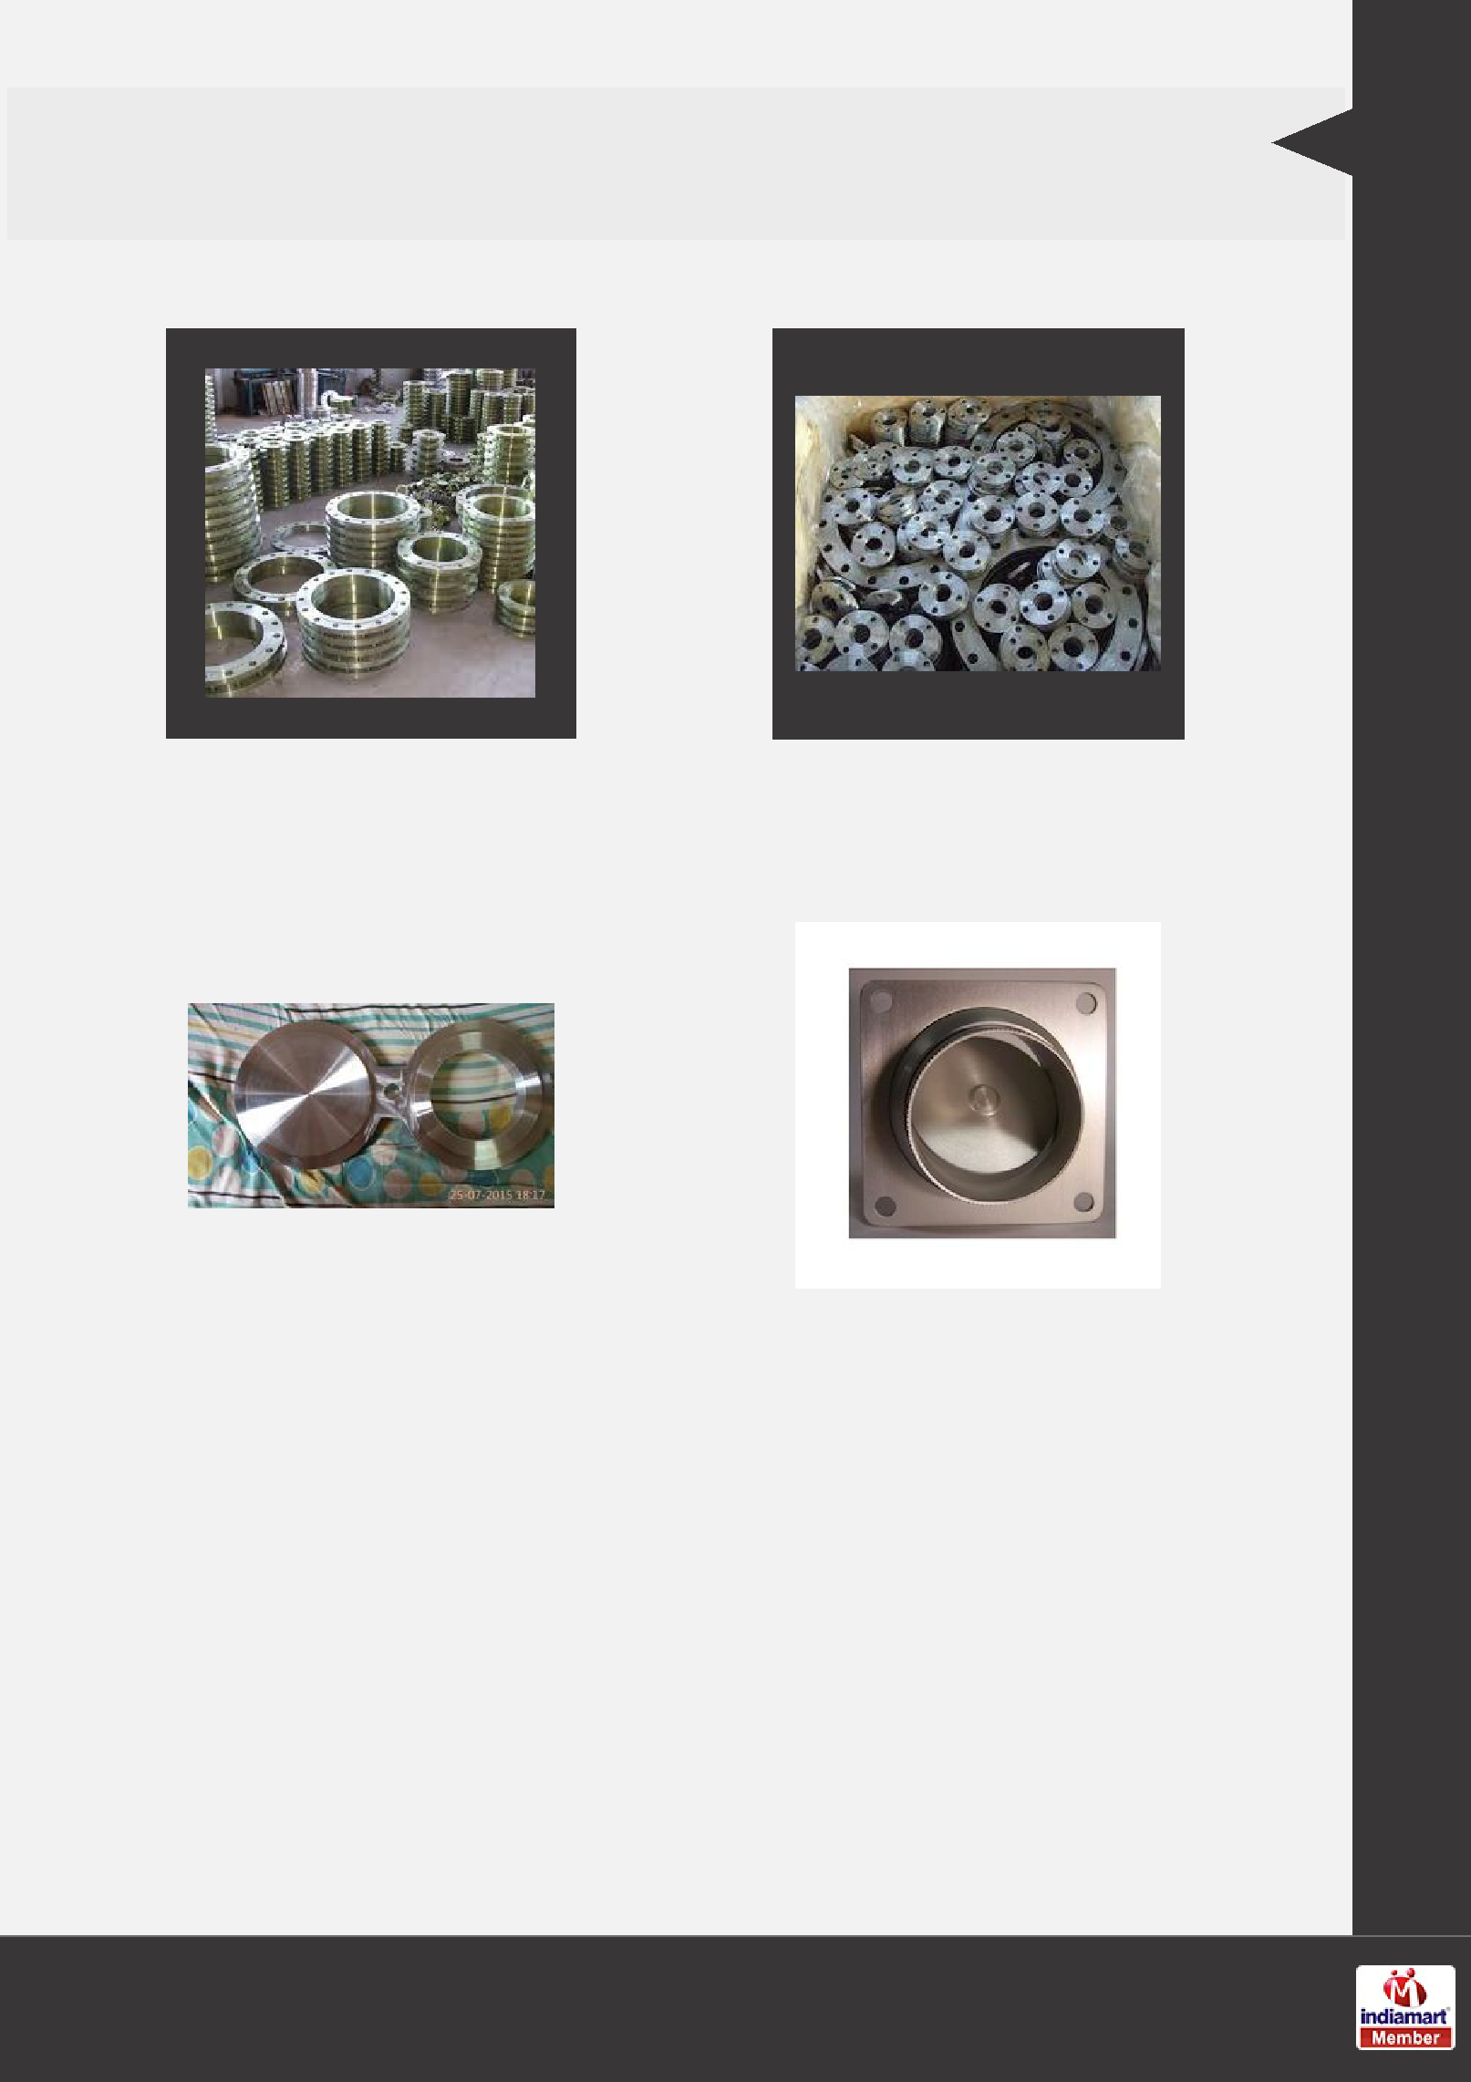
INDUSTRIAL FLANGES

Flanges Flanges

Duplex Spectacle Blind |  | Square Flanges
Flange

Our Products

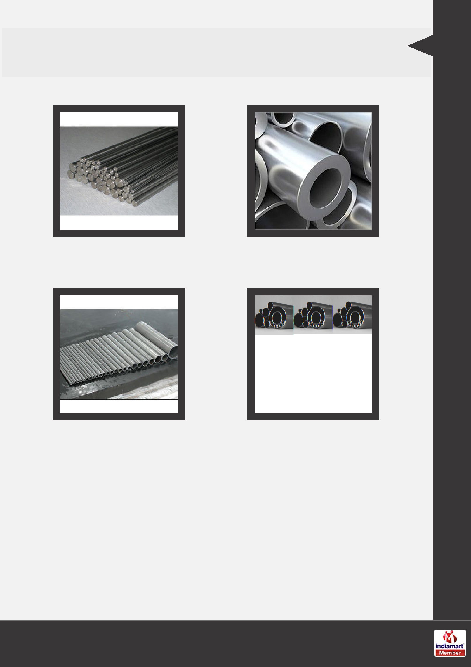
NICKEL ALLOY

Monel Round Bars Hastelloy Tubes

Nickel Alloy Nickel Alloy

Our Products

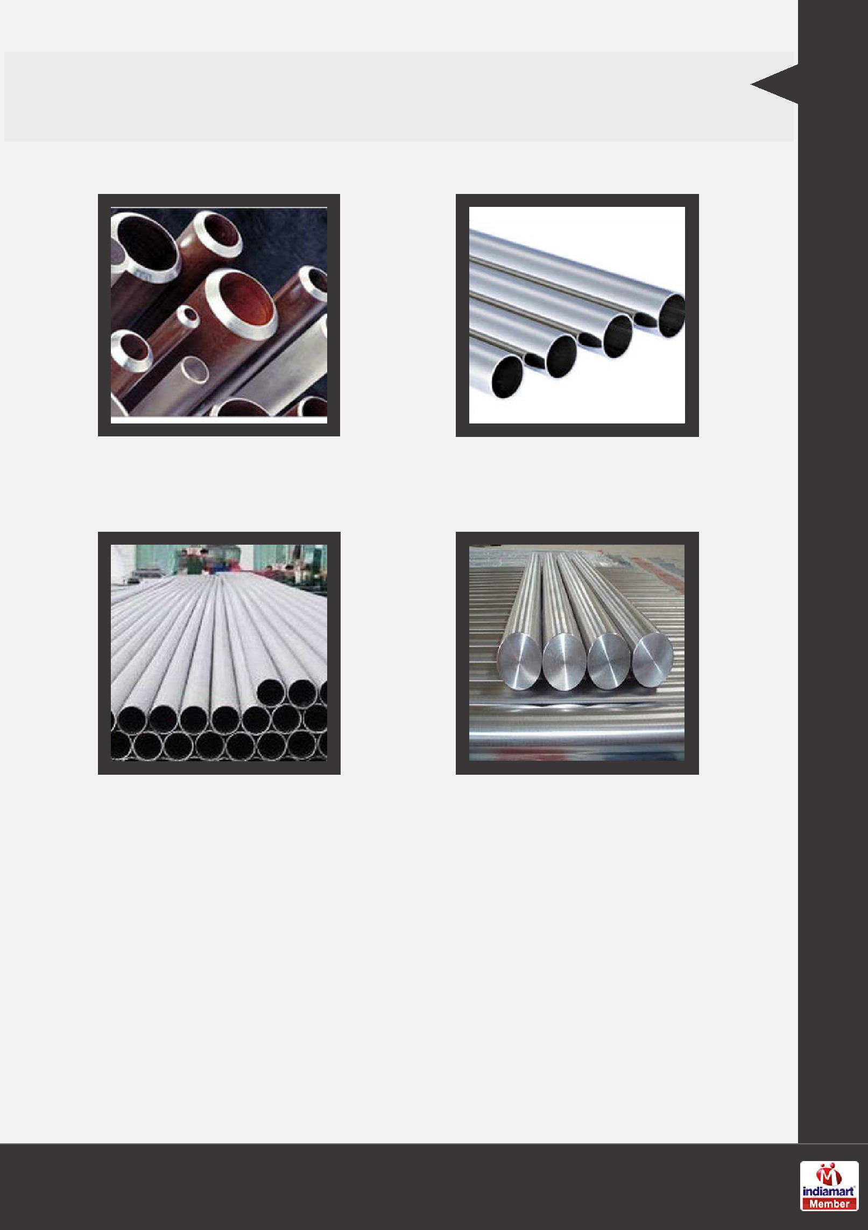
INCONEL PIPES

Inconel Pipes and Tubes Inconel 601 Pipes & Tubes

Inconel Pipe ERW Pipe Titanium Bright Bars

Our Products

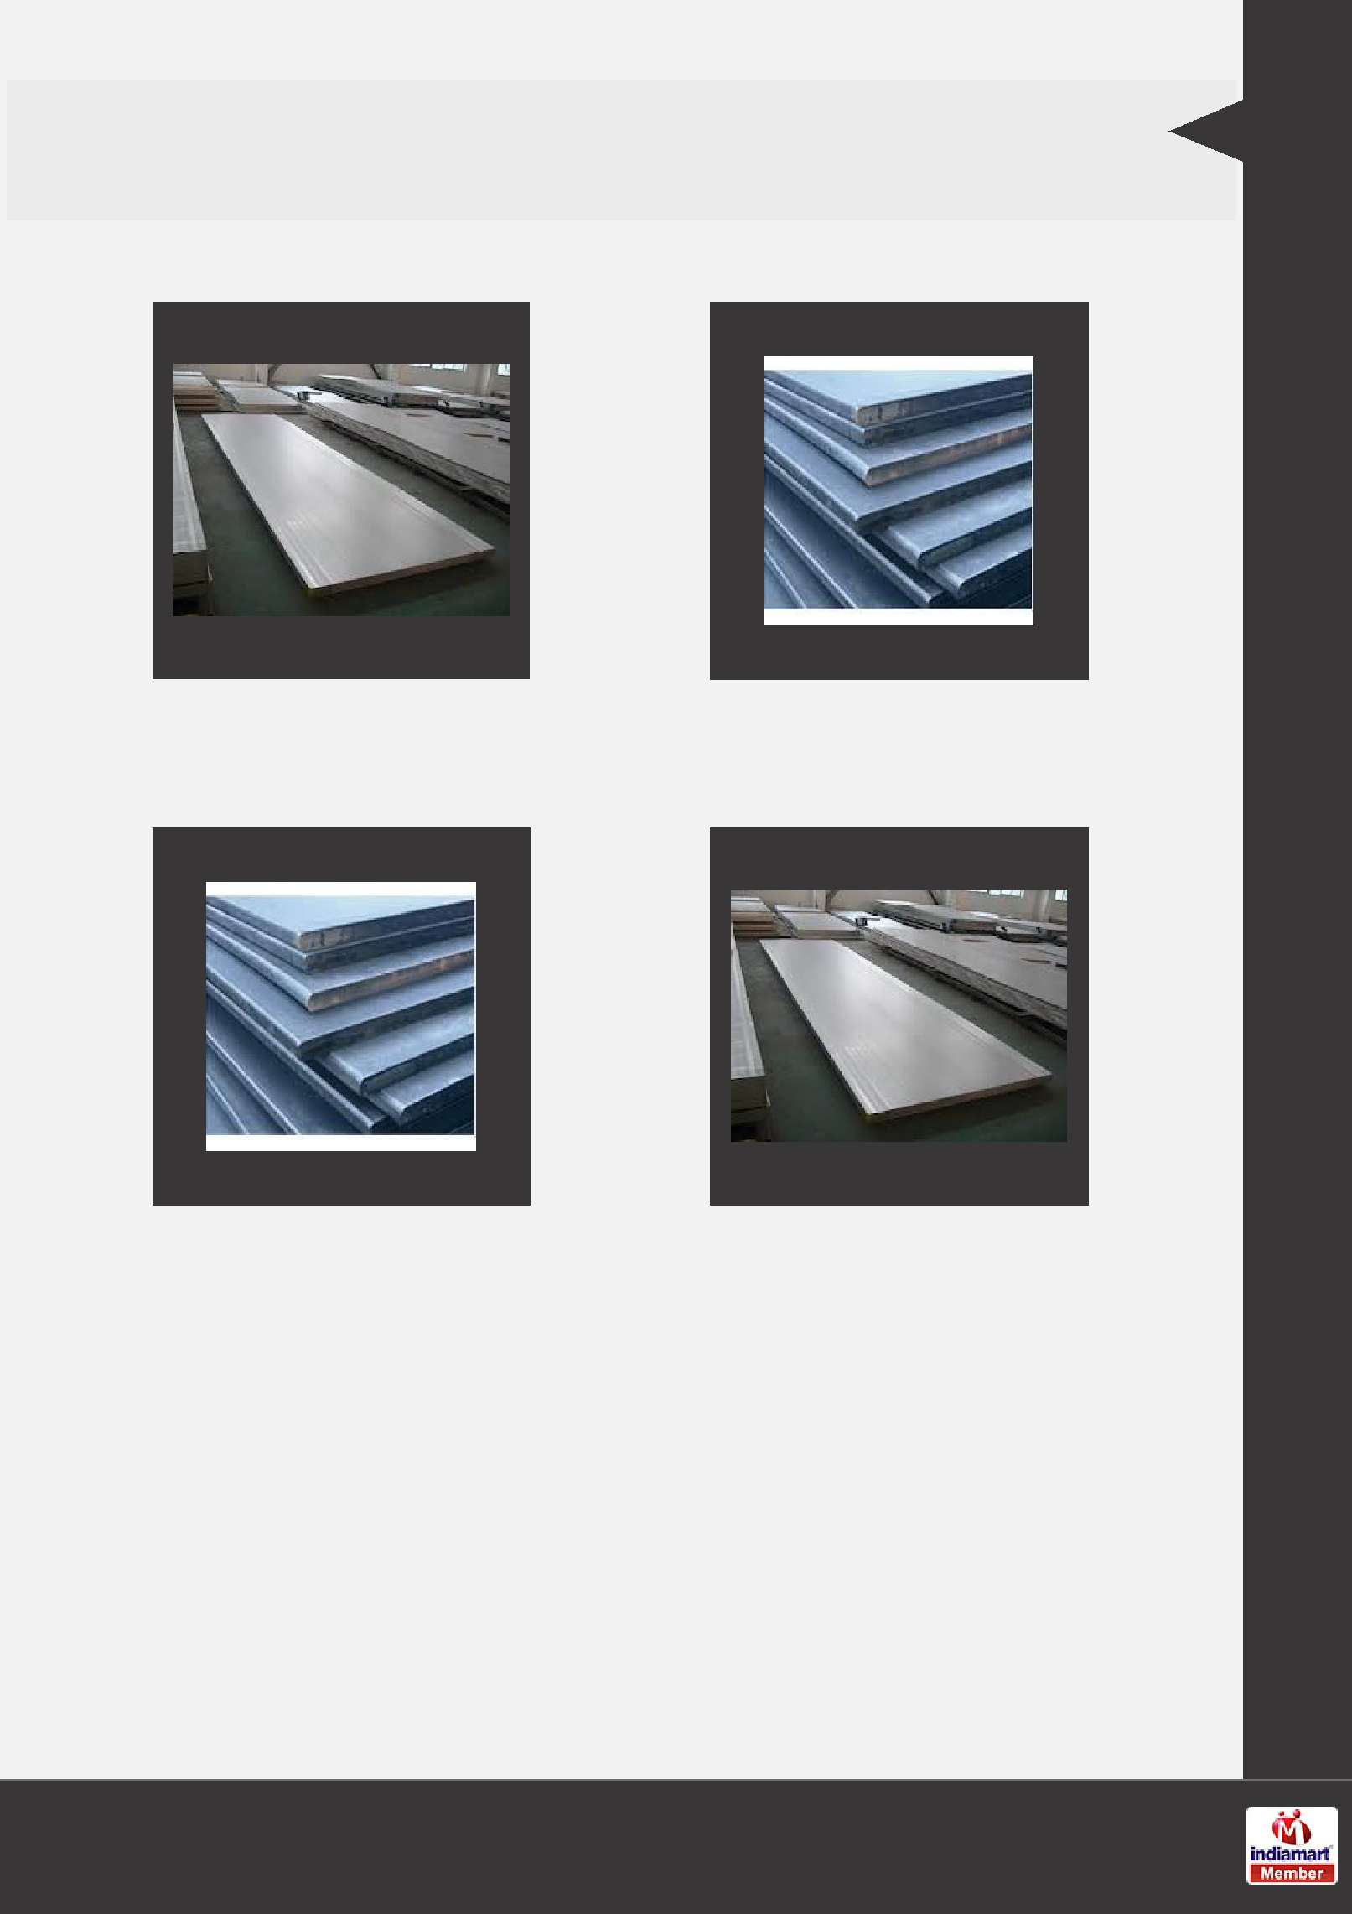
HIGH TENSILE PLATES

High Tensile Plate High Tensile Plates

High Tensile Plates - High Tensile Plates- Salima

Salima 350 410

Our Products

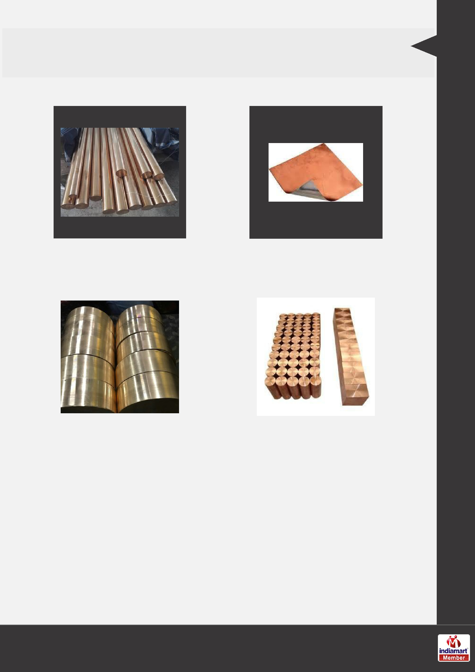
BRASS PRODUCTS

Beryllium Copper Round |  | Bimetallic Strips
Bar
Beryllium Copper Round C17500 Beryllium Copper

Bar C17200

Our Products

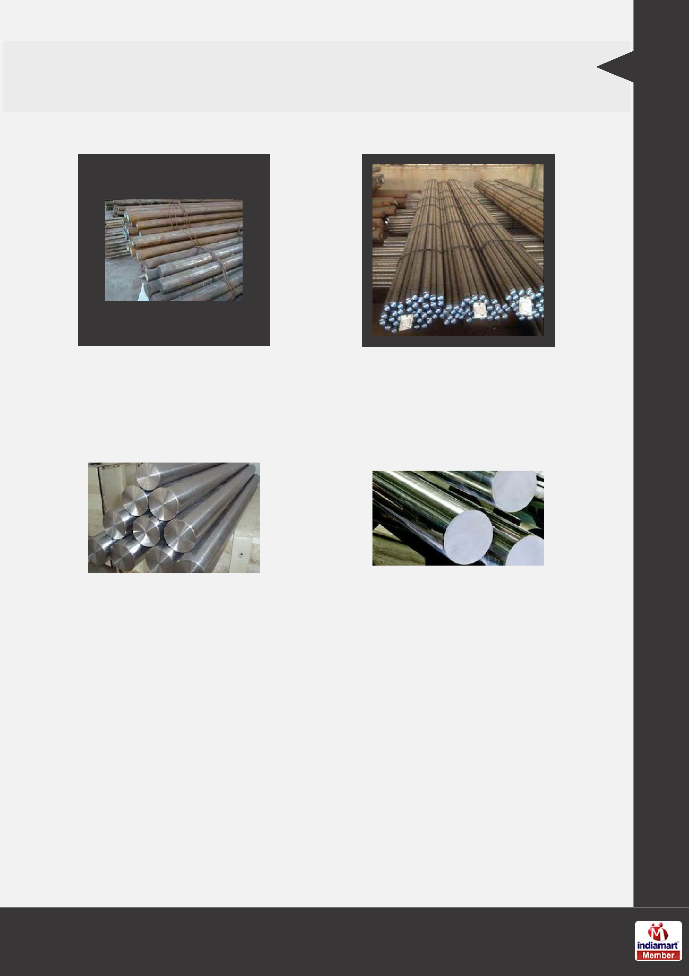
BARS

D2/D3 Round Bar EN8 Round Bars

Duplex Round Bars 2205/ |  | Super Duplex Round Bars
2207

Our Products

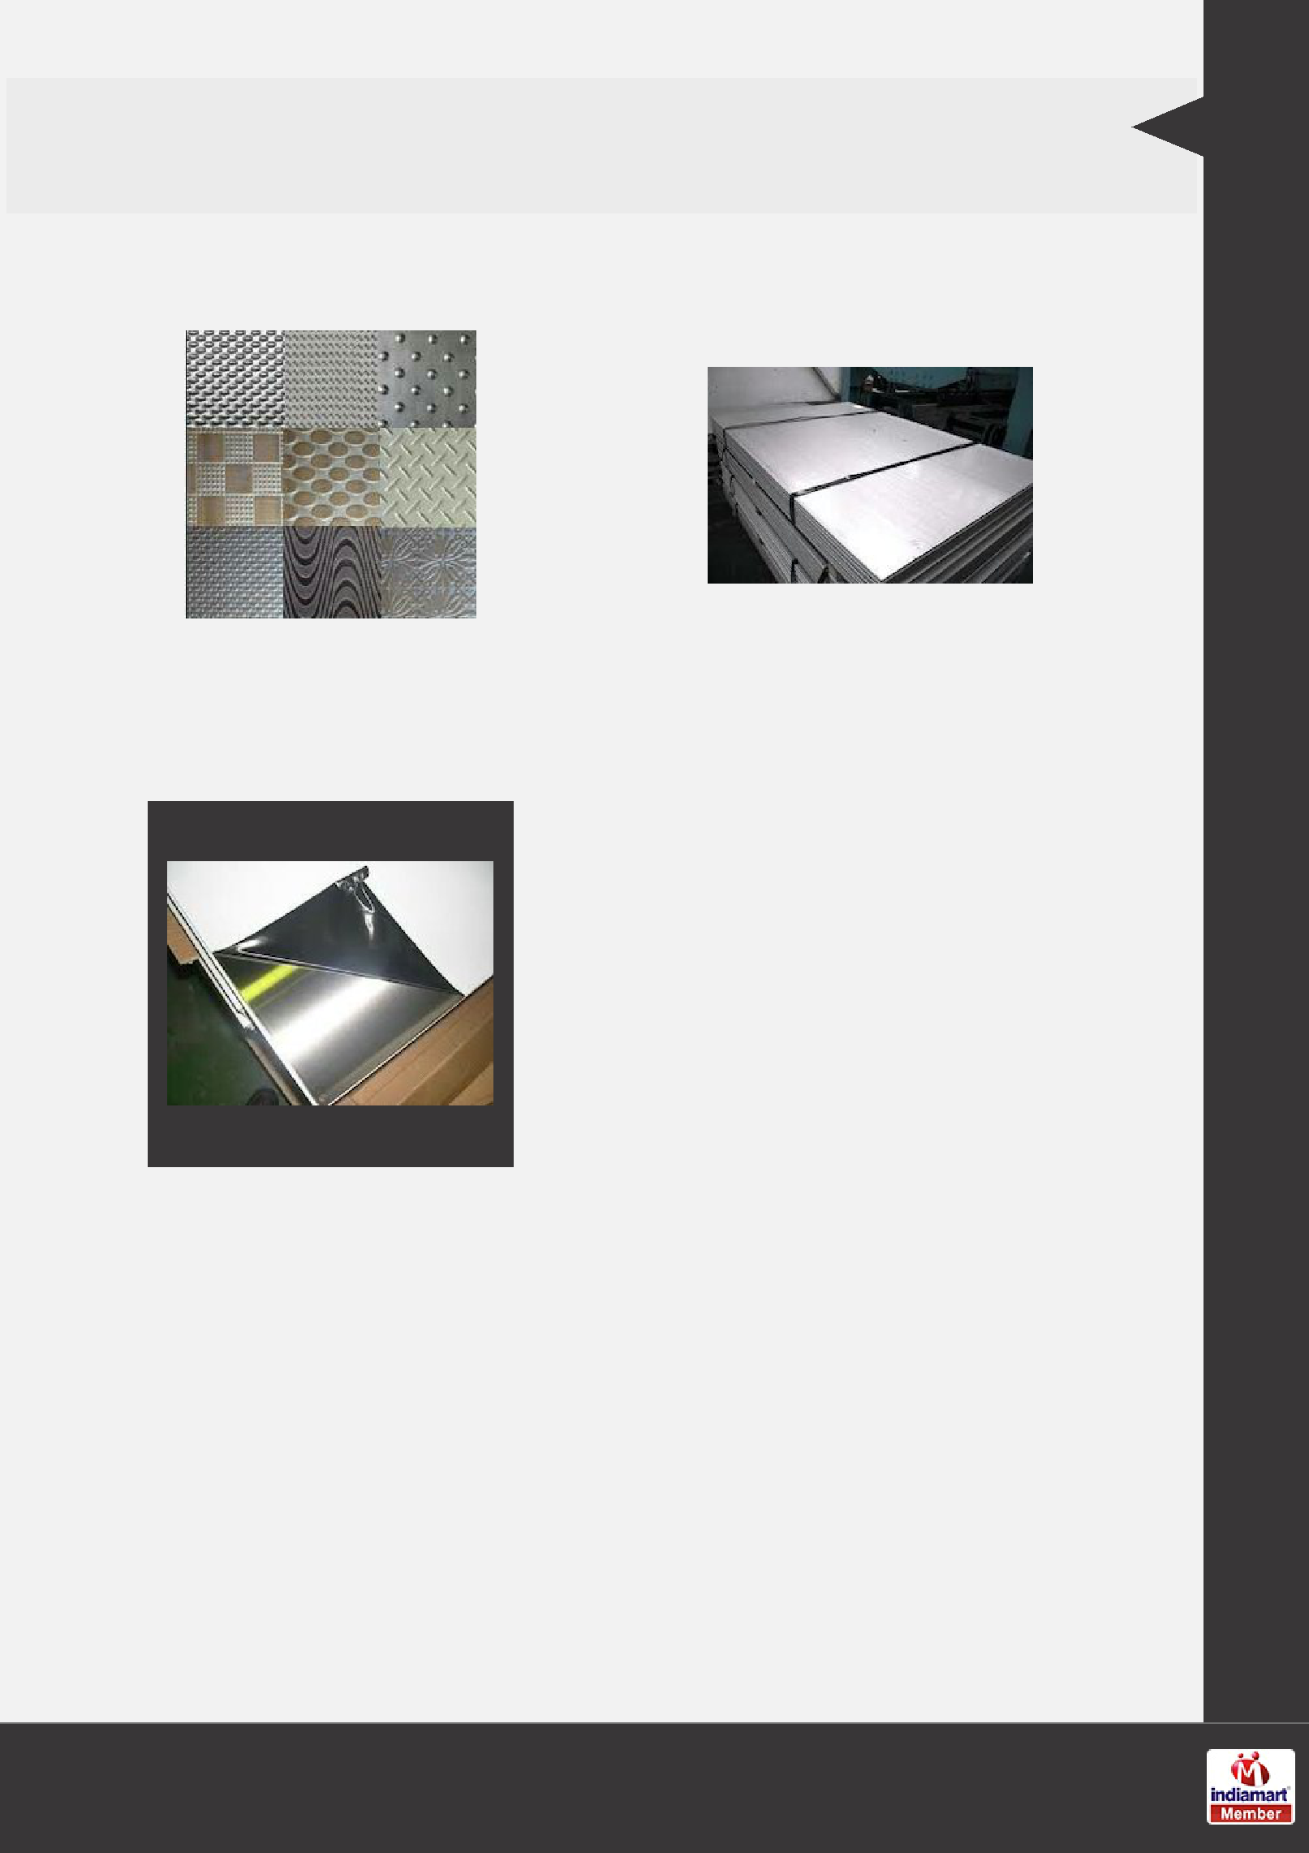
SS SHEET & PLATES

Designer Stainless Steel |  | Stainless Steel HR Plates
Sheets

Mat PVC Stainless Steel

Sheets

Our Products

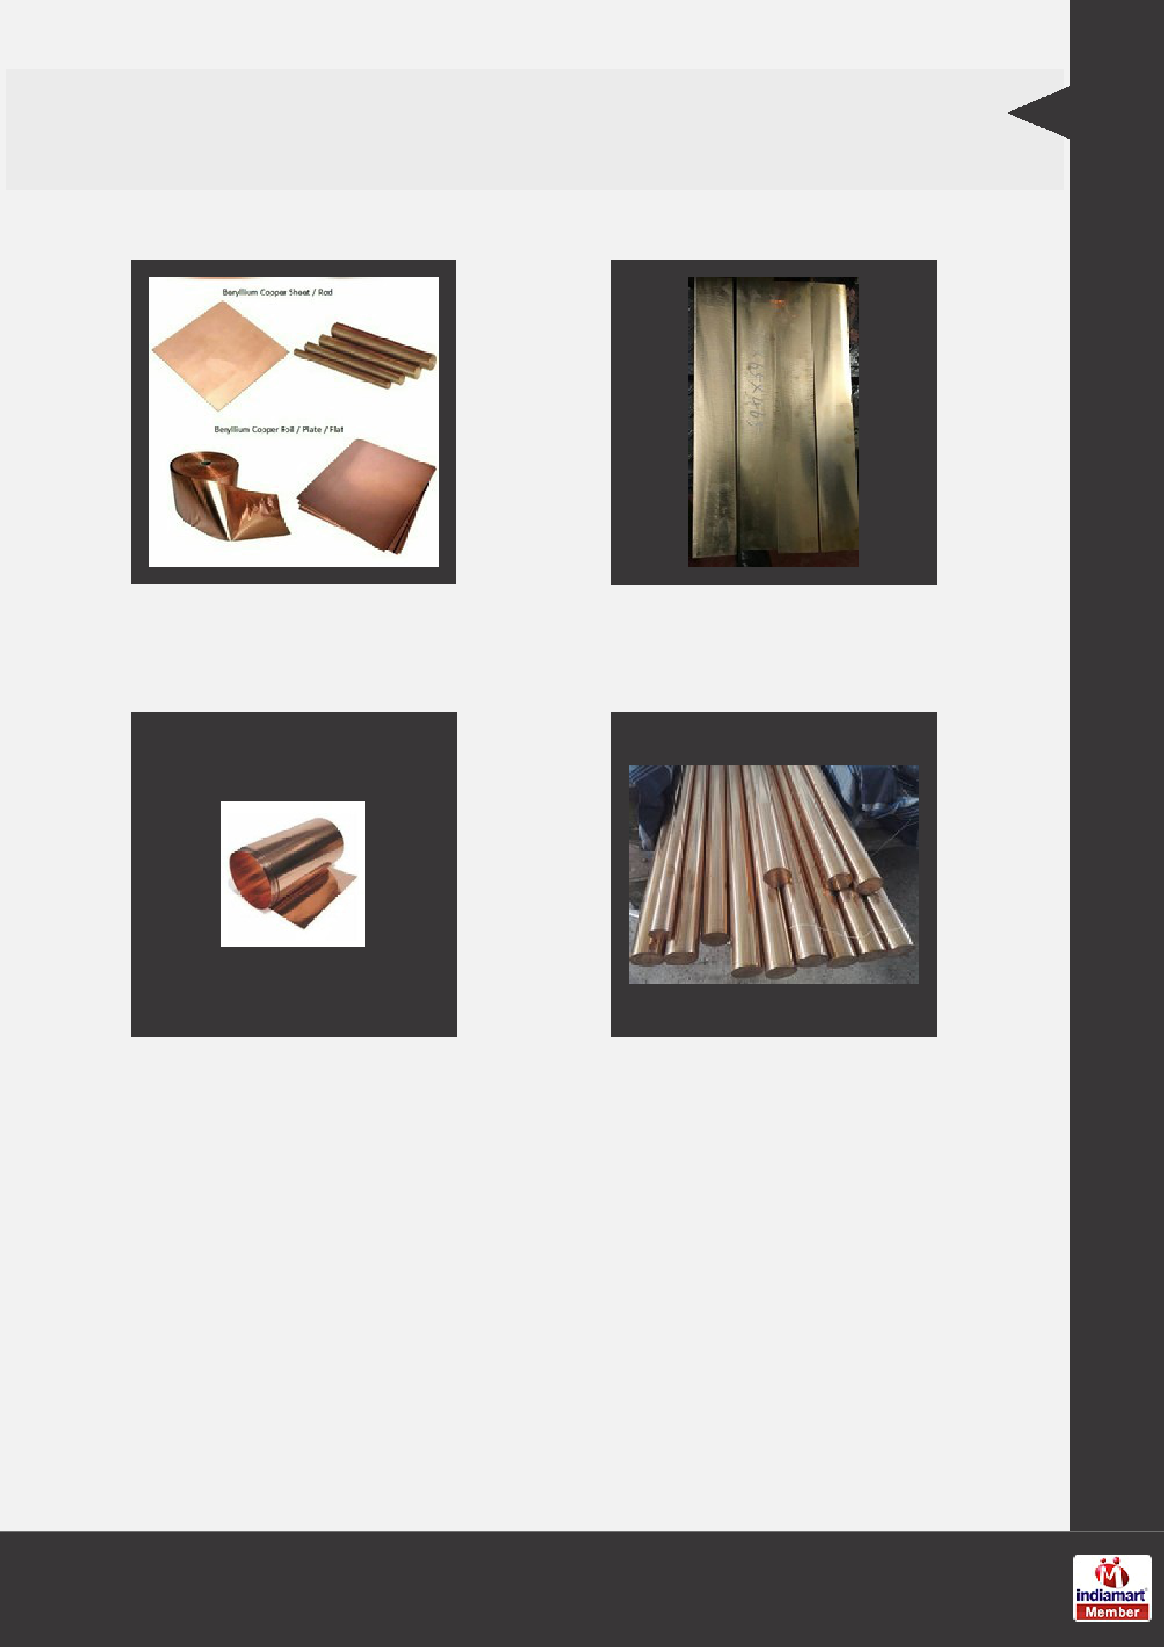
BERYLLIUM COPPER

Beryllium Copper Beryllium Copper Blocks

Beryllium Copper Shims C17200 Beryllium Copper

Our Products

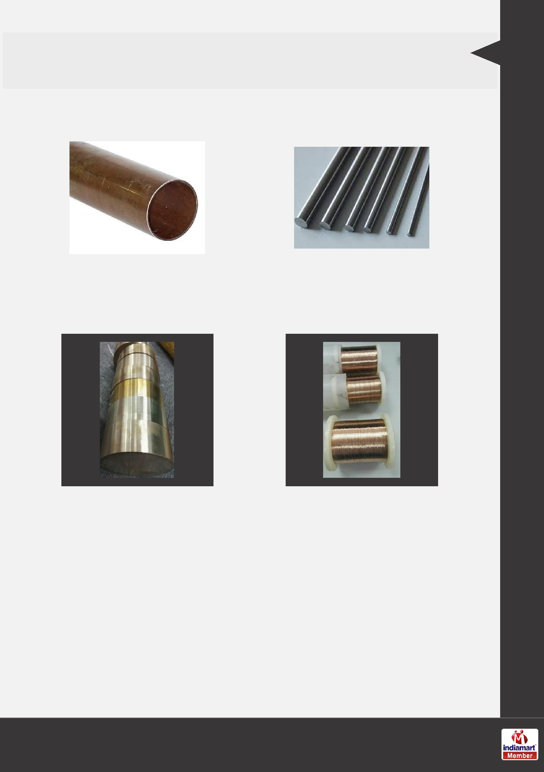
NEW ITEMS

Cupro Nickel Pipes & |  | Molybdenum Rods
Tubes

Beryllium Copper Rods Beryllium Copper Wires

Our Products

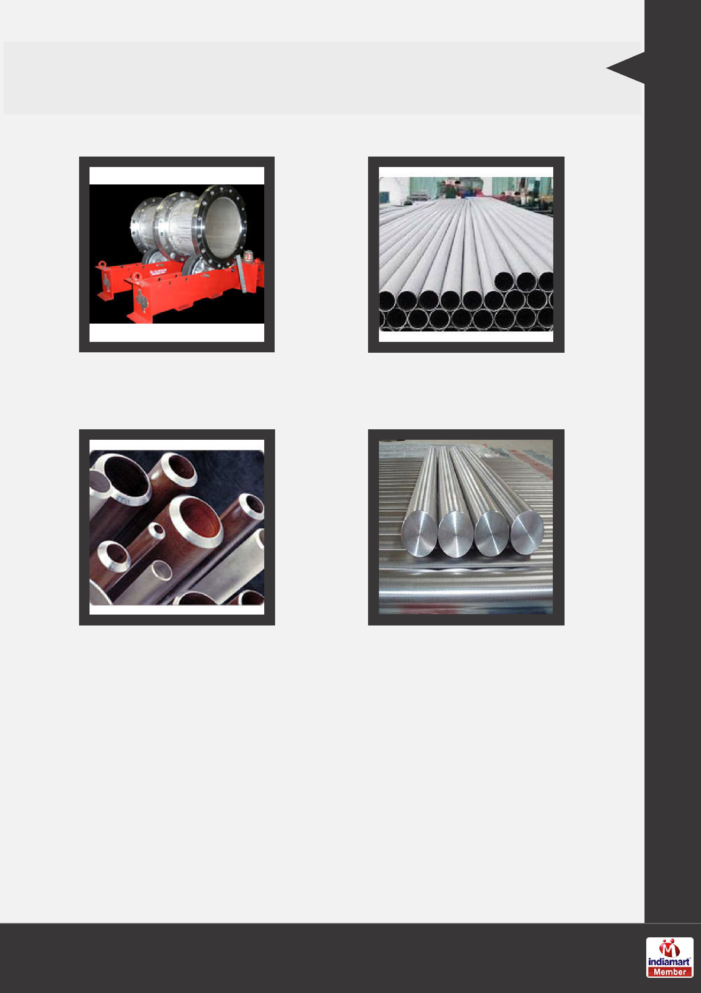
OTHER PRODUCTS:

Hastelloy Pipes and Tubes Inconel Pipe ERW Pipe

Inconel Pipes Mild Steel Round Bars

Our Products

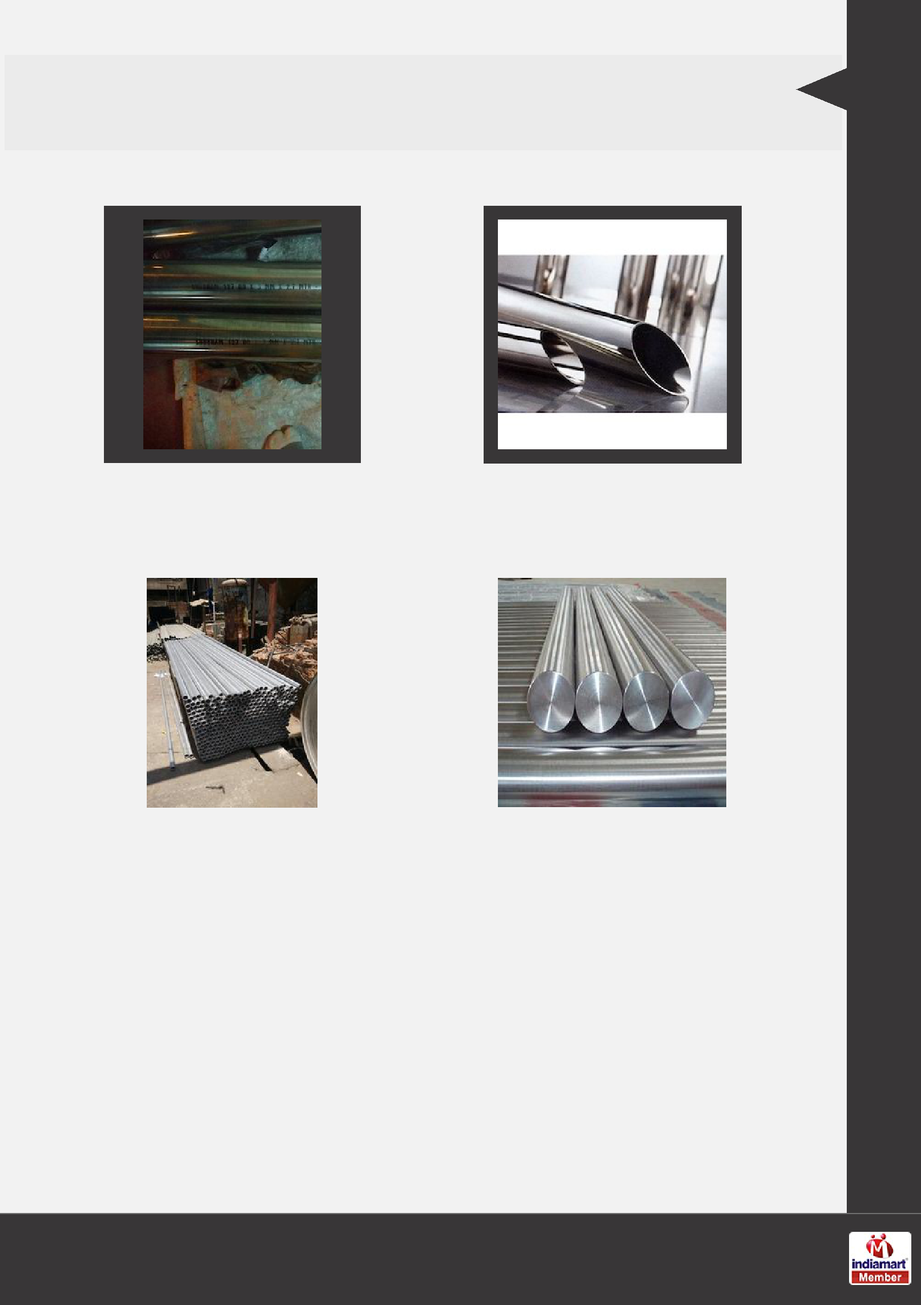
OTHER PRODUCTS:

Stainless Steel 446 Pipes & |  | Stainless Steel Pipes &
Tubes |  | Tubes
Titanium Pipes & Tubes Titanium Round Bars

Our Products

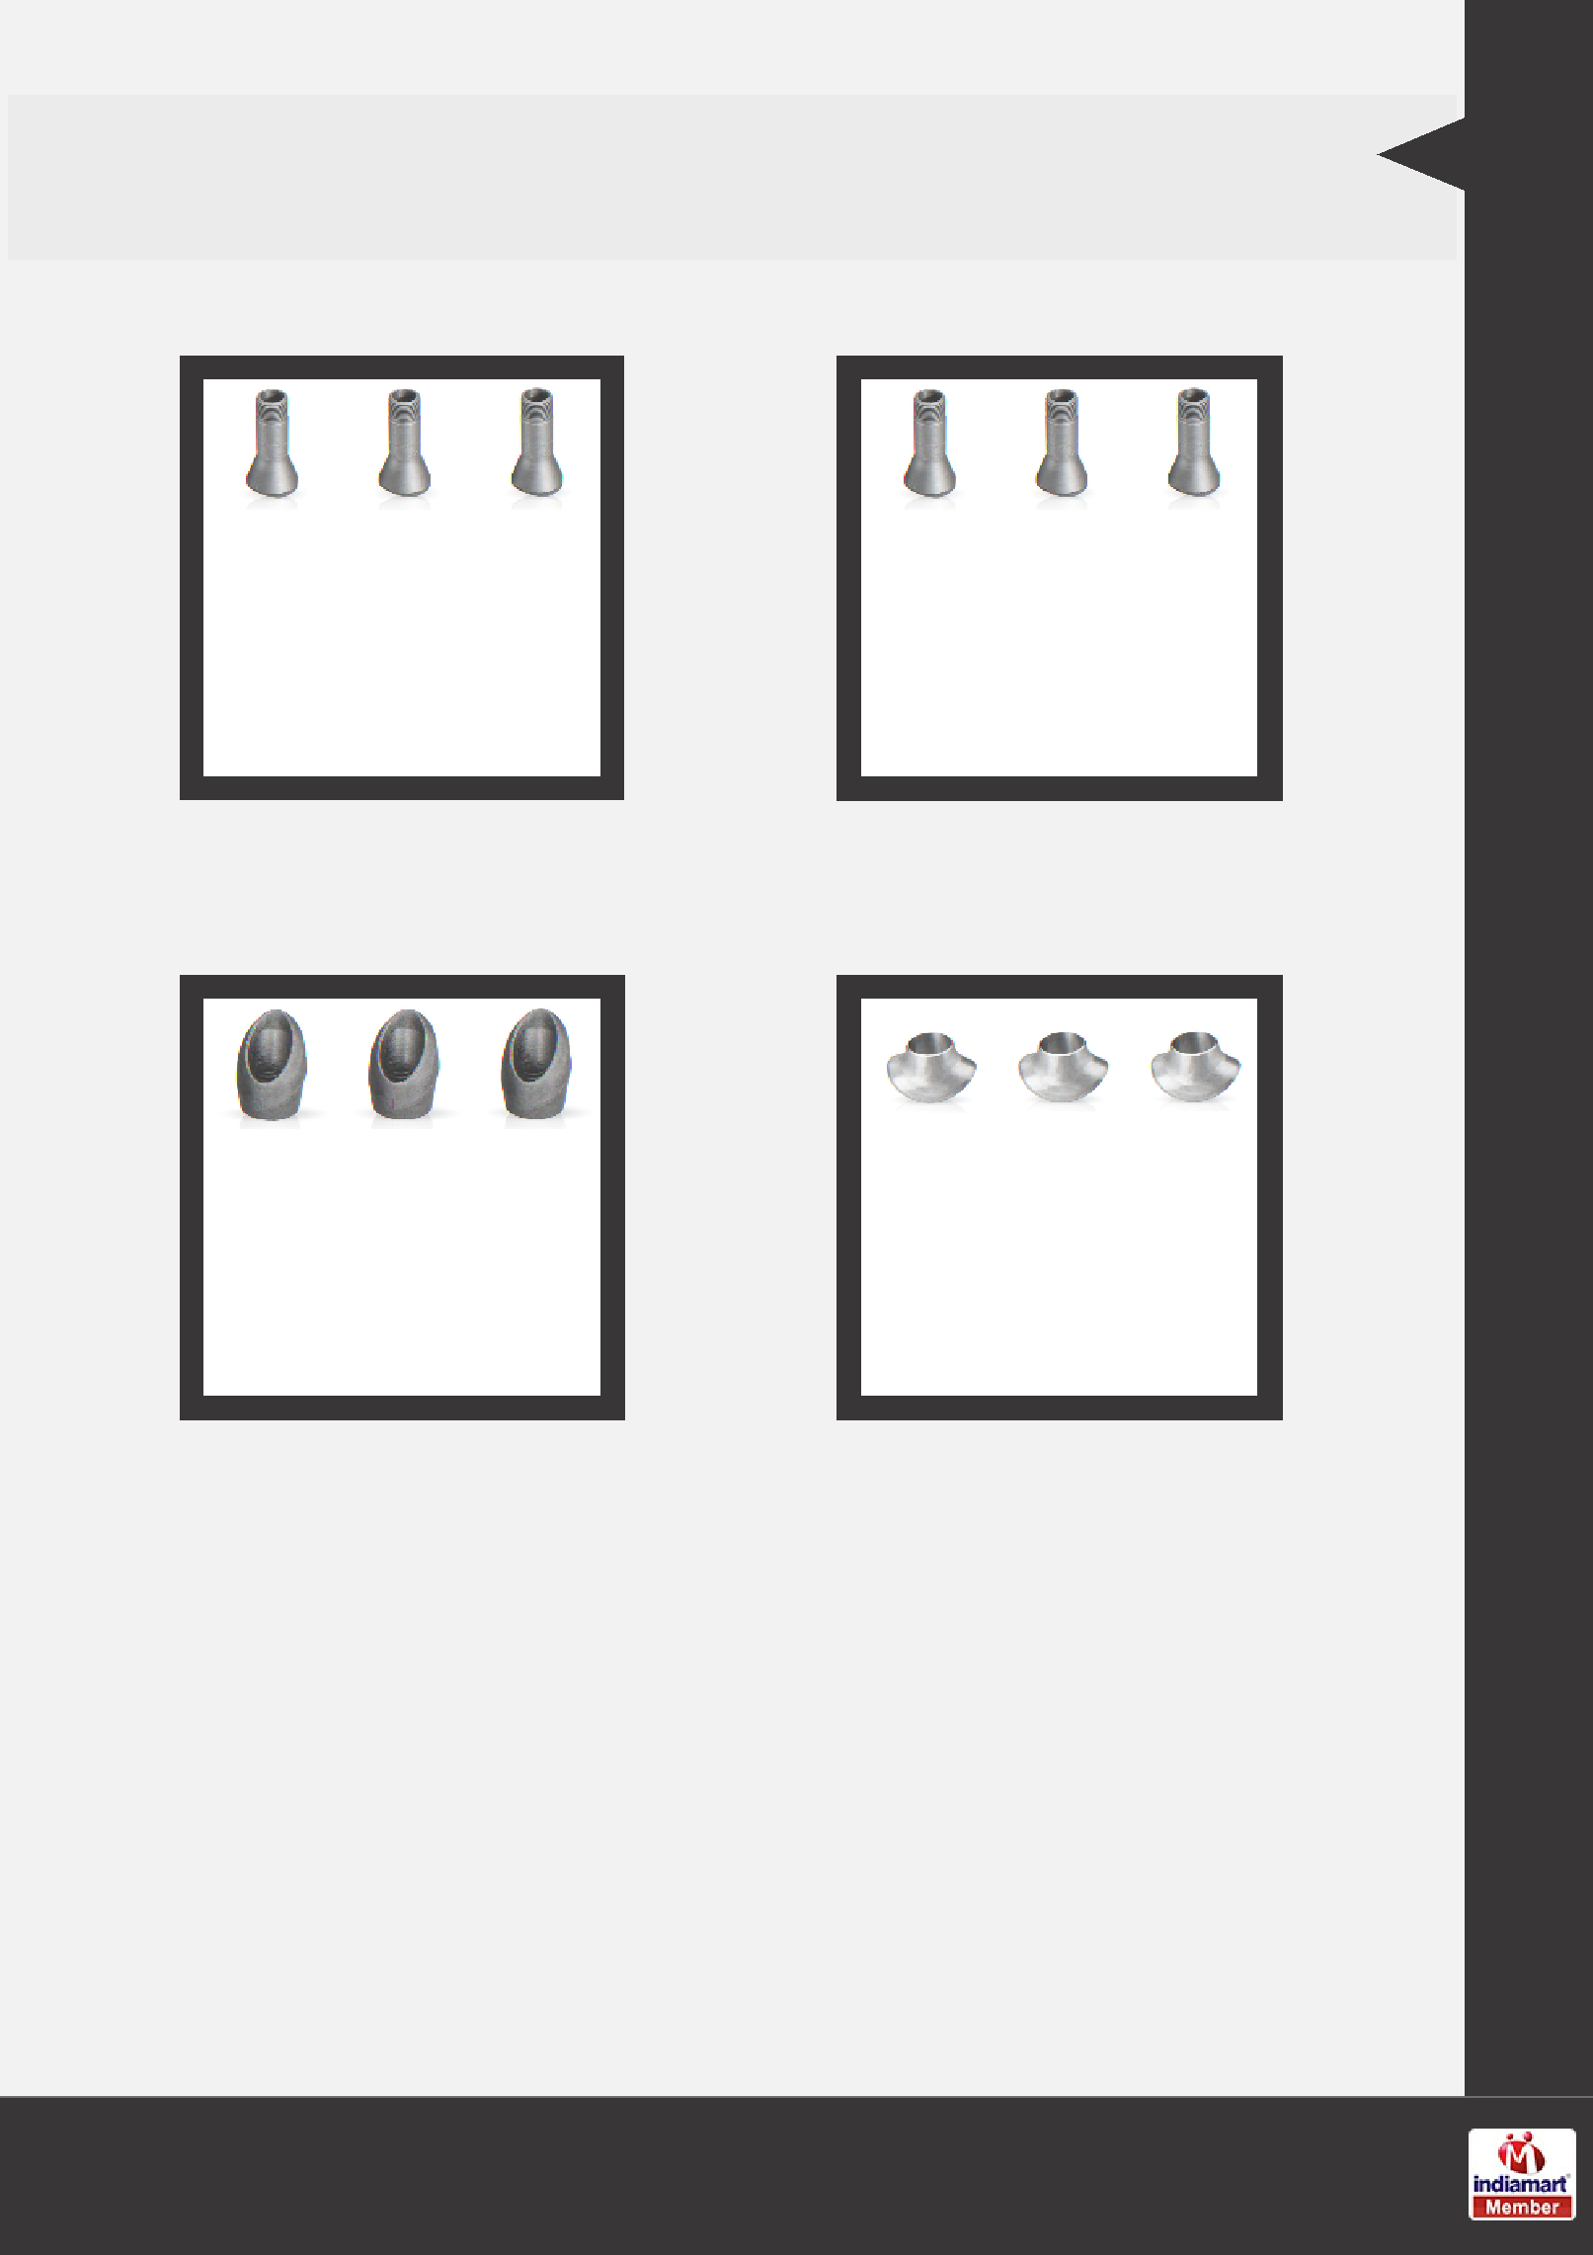
OTHER PRODUCTS:

SS Niplolet SS Latrolet

SS Elbolet SS Sweepolet

Our Products

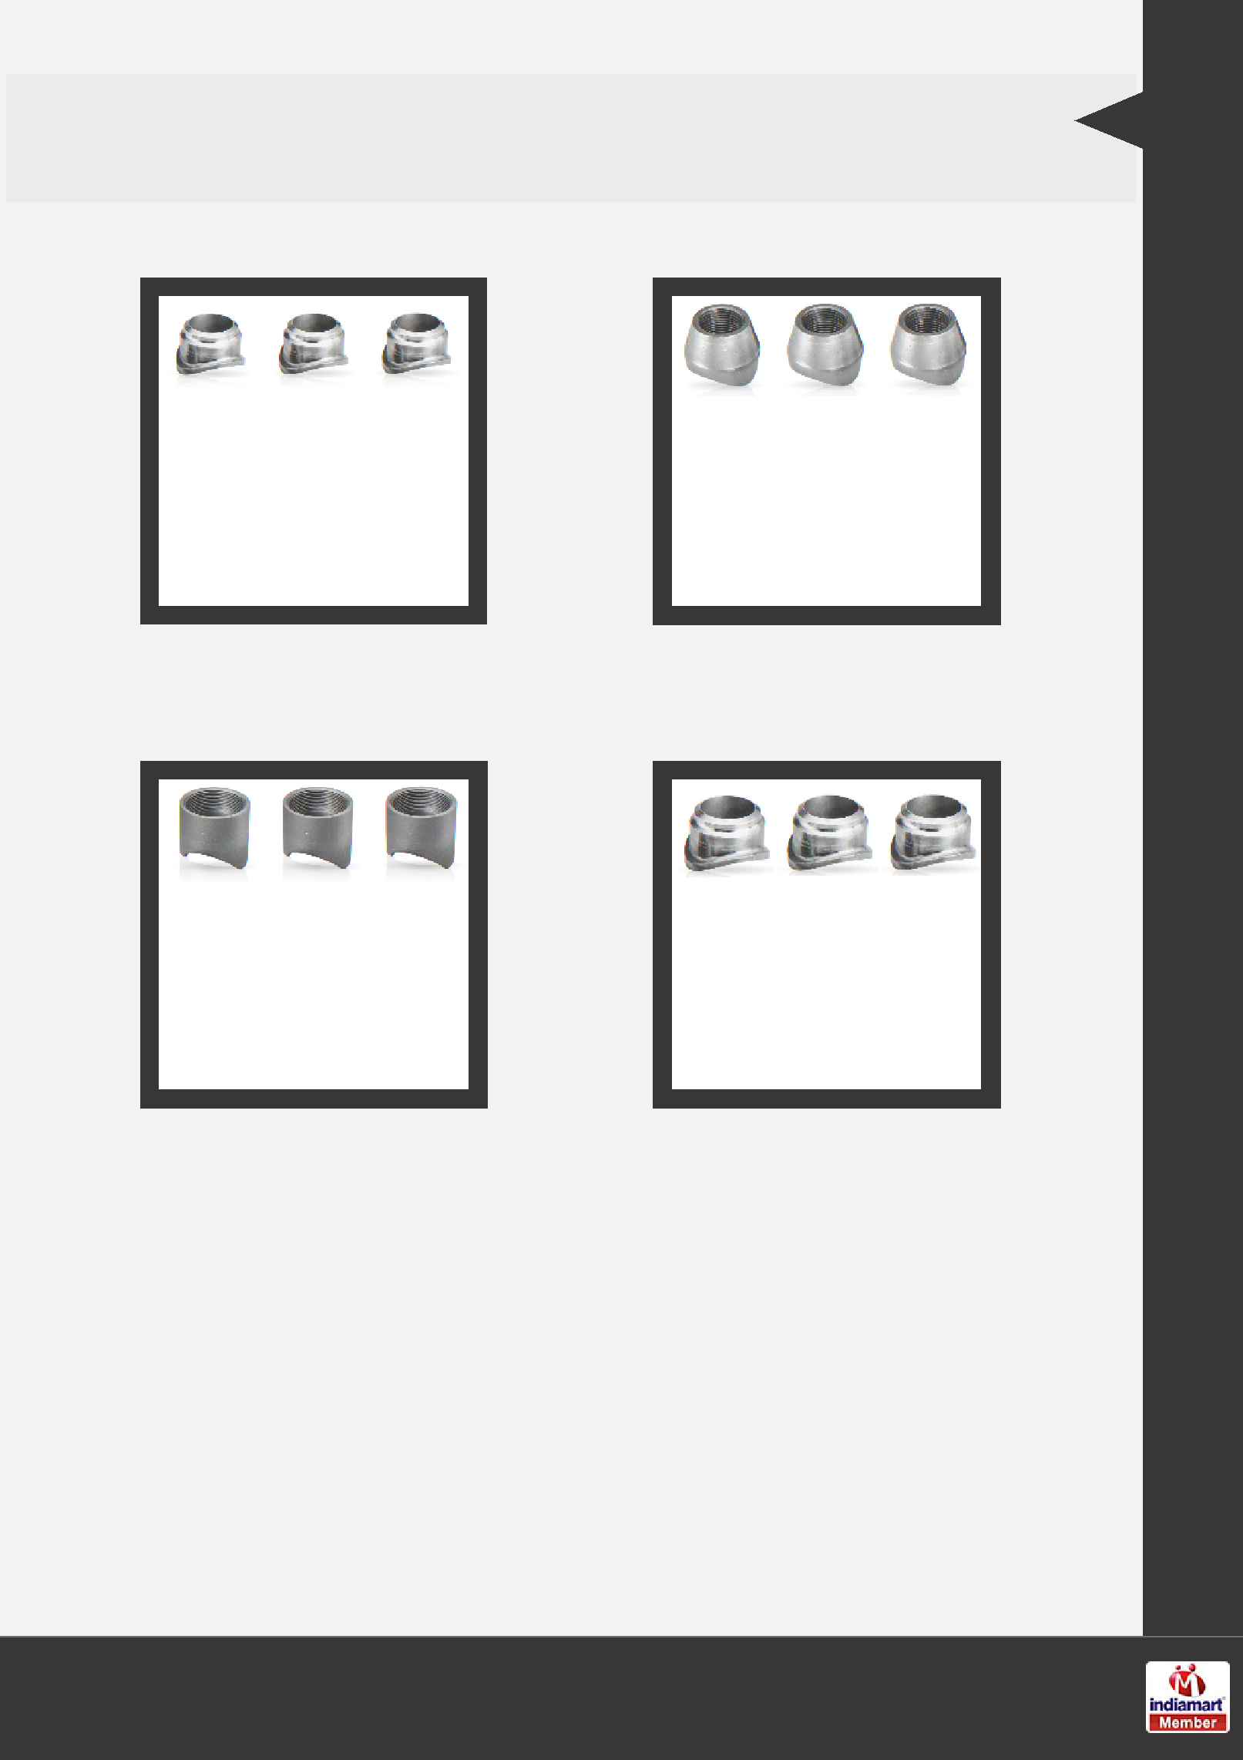
OTHER PRODUCTS:

Weldolet SS Brazolet

SS Coupolet Insert Weldolet

Our Products

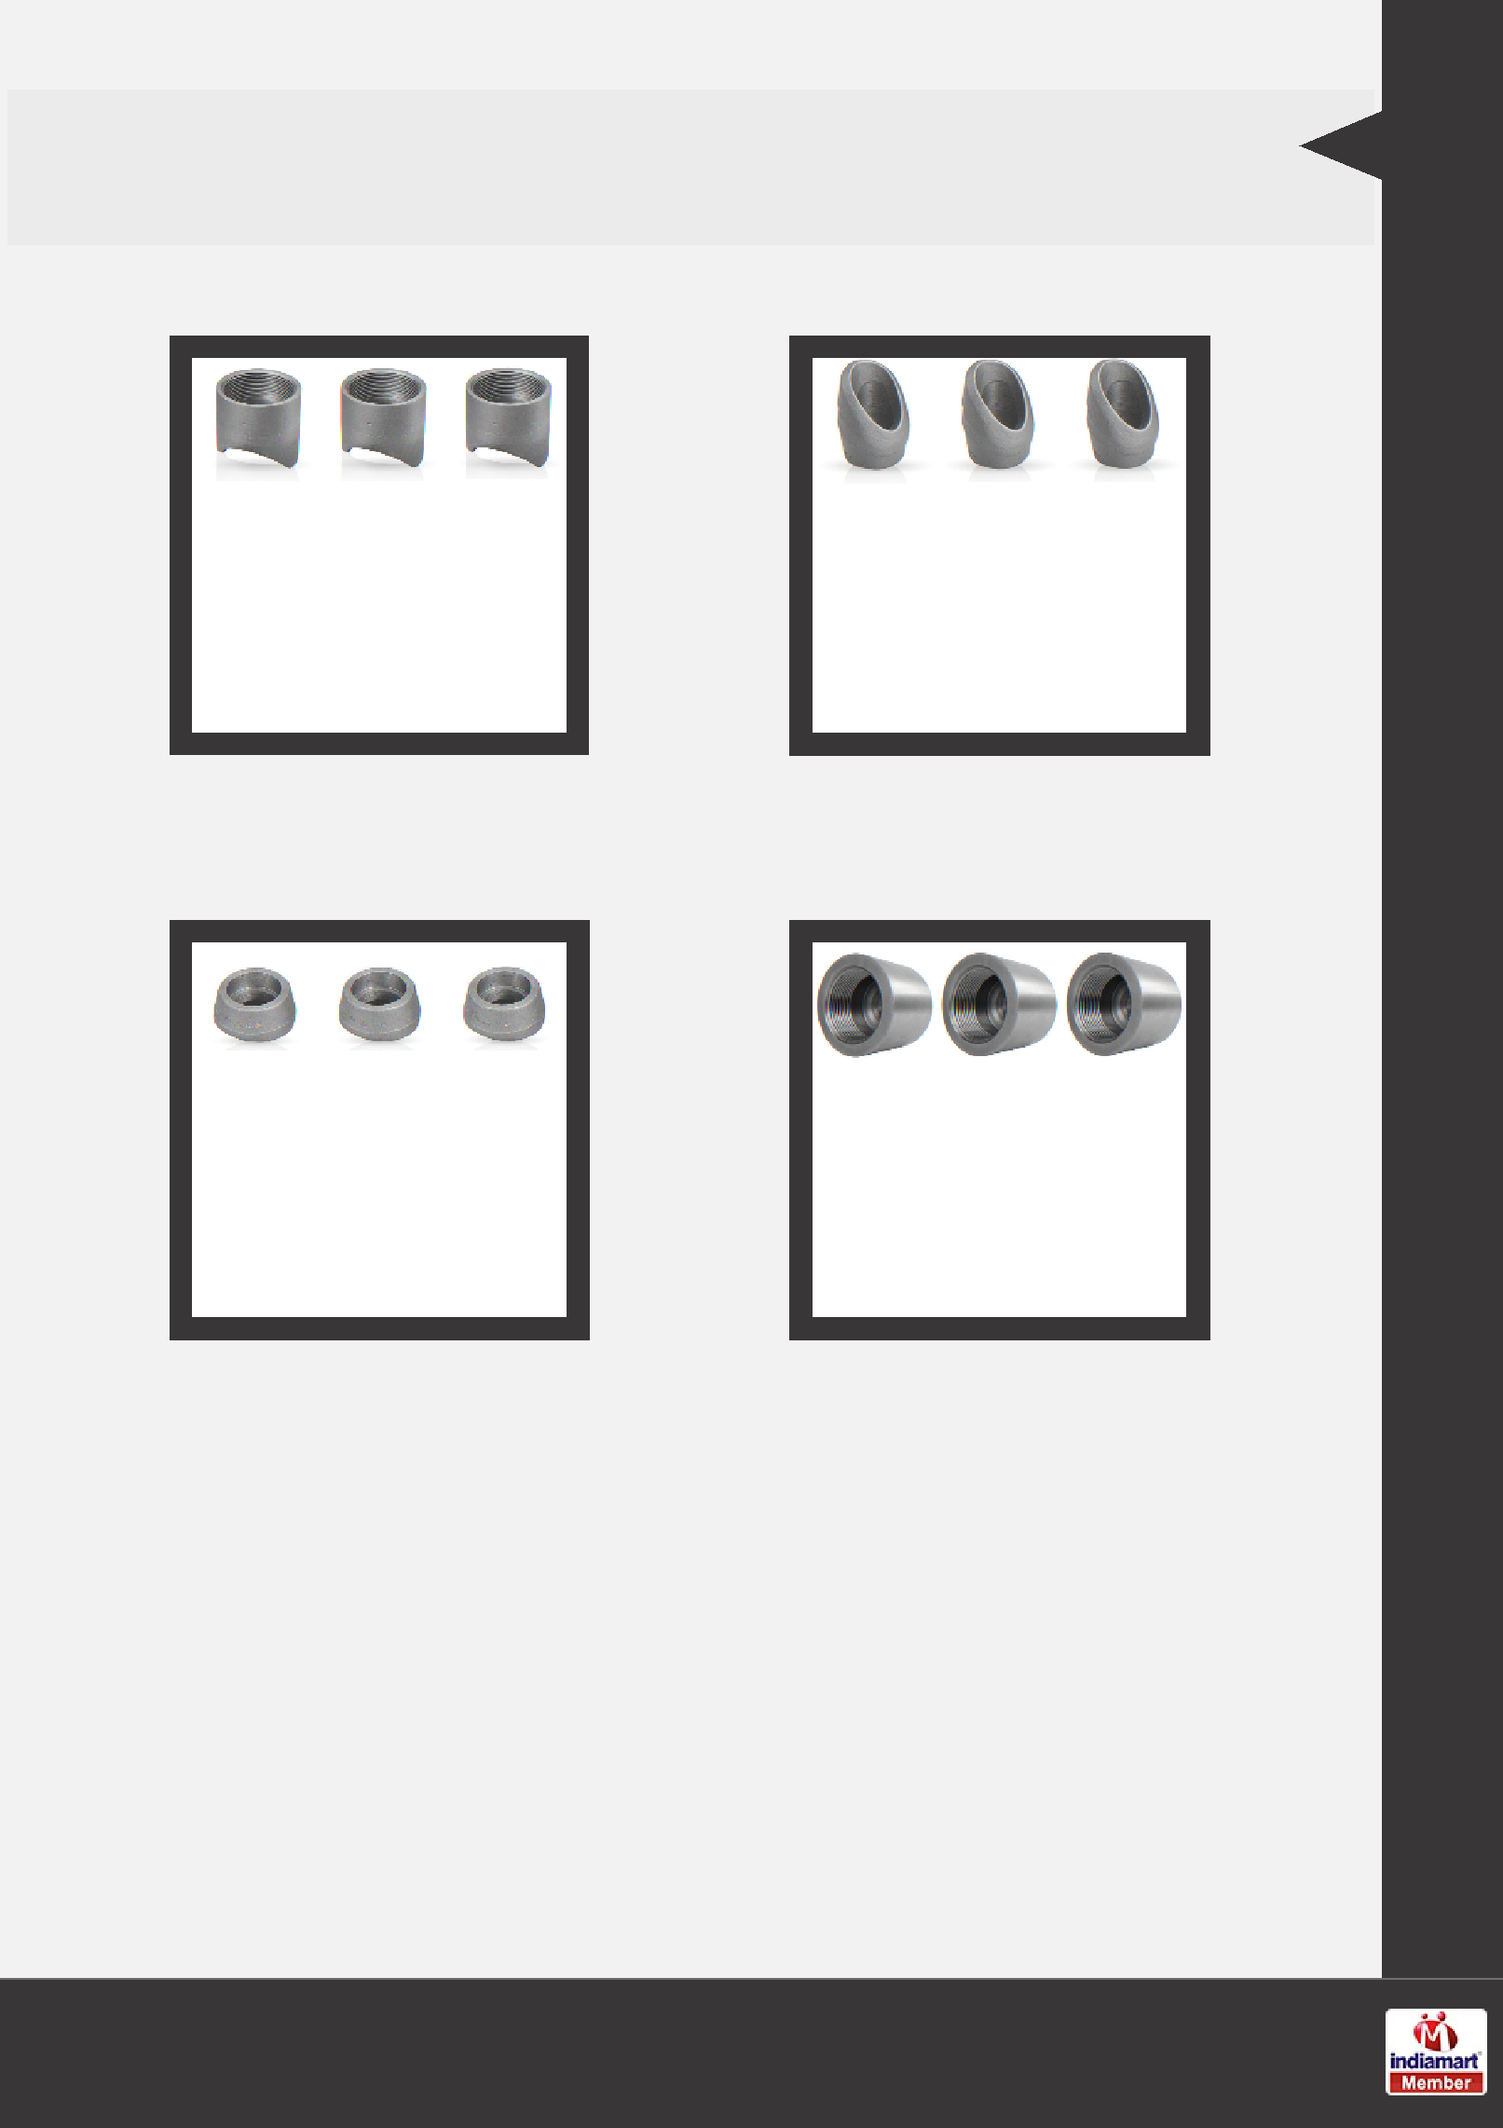
OTHER PRODUCTS:

SS Coupolet Flexolet Butt Weld

Flexolet Socket Weld Half Coupling

Our Products

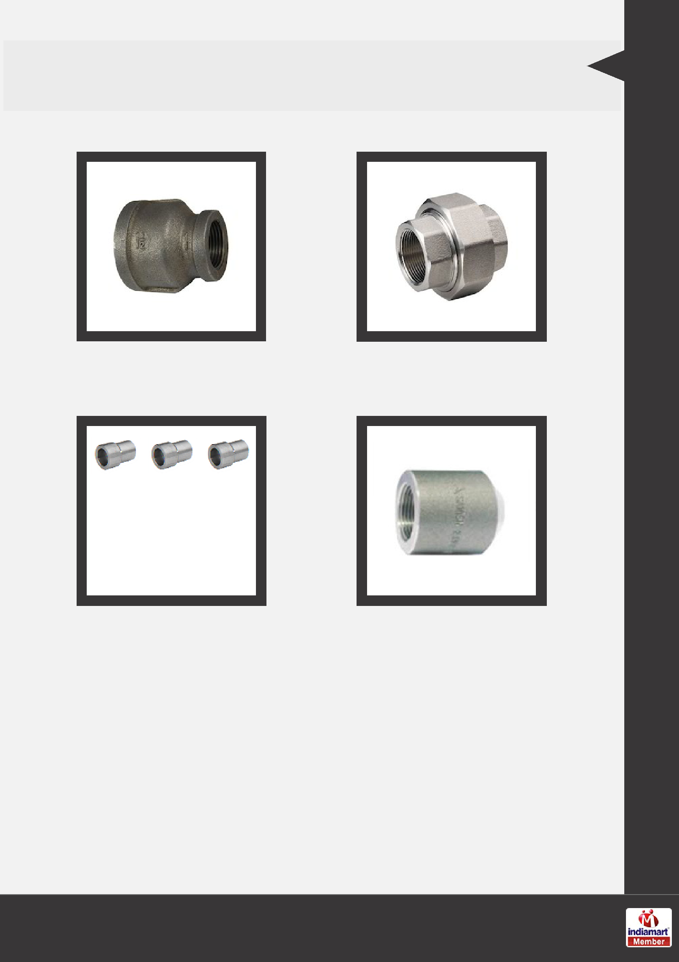
OTHER PRODUCTS:

Reducing Coupling Union Pipe Fittings

Reducer Insert Pipe Fittings

Our Products

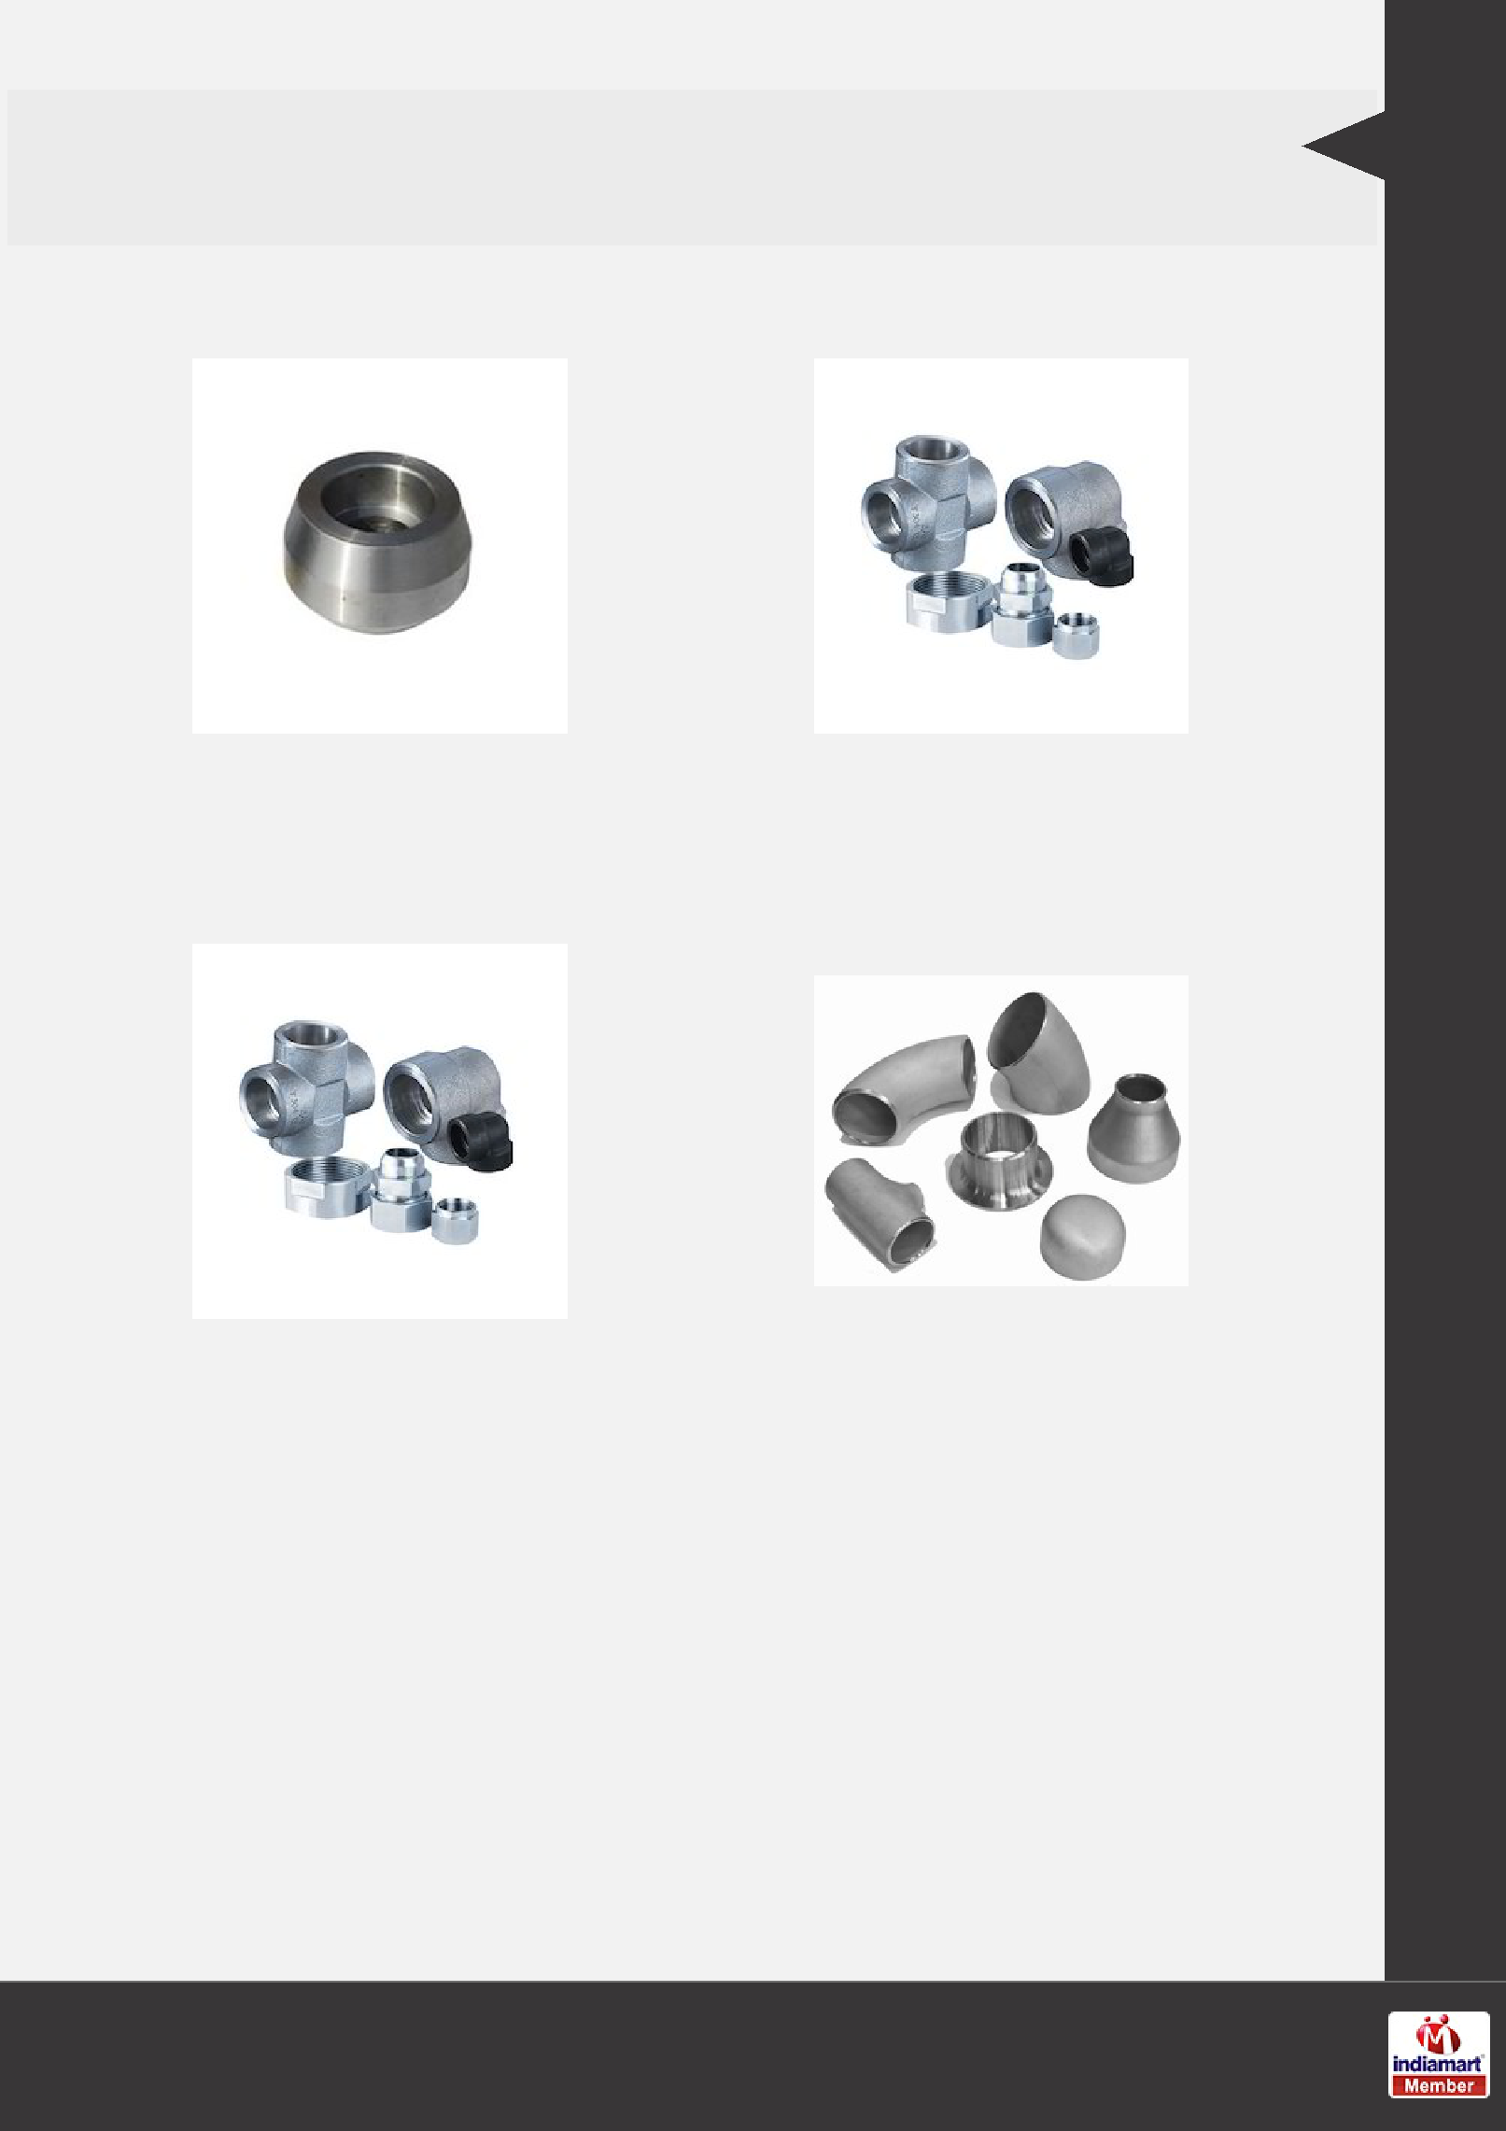
OTHER PRODUCTS:

Branch Outlet |  | Elbow Outlet Forged
 |  | Fittings
Forged Fittings Butt Weld Forged Fittings

Our Products

F a c t s h e e t

Year of Establishment | : | 2013
Nature of Business | : | Wholesale Trader
Total Number of Employees | : | Upto 10 People

CONTACT US

Shubham Enterprise

Contact Person: Vikram Doshi

No. 37, Durgadevi Street, 2nd Kumbharwada Mumbai - 400004, Maharashtra, India

+91-8048017823

http://www.projectspipefittings.com/

